**NATURAL LANGUAGE PROCESSING**

Natural Language Processing (NLP) is a field of artificial intelligence (AI) that focuses on the **interaction between computers and human language**. The goal of NLP is to enable computers to understand, interpret, and generate human language in a way that is both meaningful and useful.

NLP involves a wide range of tasks and techniques that enable computers to work with natural language. Some of the key areas within NLP include:

1. **Text Analysis**: This involves tasks such as text classification (categorizing text into predefined categories), sentiment analysis (determining the emotional tone of a piece of text), and named entity recognition (identifying and categorizing named entities like names, dates, and locations).

2. **Machine Translation**: This area focuses on developing systems that can automatically translate text from one language to another. Prominent examples include Google Translate.

3. **Speech Recognition**: This involves converting spoken language into written text. Speech recognition technology is used in applications like voice assistants (e.g., Siri, Alexa) and transcription services.

4. **Information Retrieval**: This involves finding relevant information from a large collection of documents or text. Search engines like Google utilize NLP techniques to provide accurate search results.

5.**Question Answering**: This area involves developing systems that can understand questions posed in natural language and provide accurate answers. IBM's Watson is an example of a system that excels in question answering.

6. **Text Generation**: This includes generating human-like text, which could be used for chatbots, content generation, or creative writing.

7. **Language Generation**: This is a broader concept than text generation and includes generating not only text but also other forms of language expression like speech and poetry.

8. **Language Understanding**: This involves developing models that can understand the meaning of sentences beyond surface-level structures, taking into account nuances, context, and implied meanings.

9. **Summarization**: Automatic summarization involves condensing lengthy texts into shorter versions while retaining the key information.

10. **Language Models**: NLP has seen significant advancements with the development of large-scale language models like GPT (Generative Pre-trained Transformer). These models can generate coherent and contextually relevant text given a prompt.

NLP techniques often involve machine learning and deep learning approaches, such as recurrent neural networks (RNNs), convolutional neural networks (CNNs), and transformer models. These models learn patterns and relationships in language data, enabling them to perform various language-related tasks.

NLP has a wide range of applications, including but not limited to, customer support chatbots, language translation services, sentiment analysis for social media monitoring, medical record analysis, legal document review, and more. As NLP technology continues to advance, it is becoming increasingly integrated into our daily lives and shaping how we interact with computers and machines.

Instructors- Younes and Lukasz

 In course one, we will learn to distinguish between pieces of text with positive sentiments and negative sentiments.

We will do so using logistic regression and naive Bayes classifiers.

We will also learn to represent words, queries and documents including other pieces of text as numbers in vectors.

We will build your first machine translation system and we will learn about locality sensitive hashing which is just a method, that will help us with efficient search.

After the first course, you then go on to the second course in which you learn probabilistic models in NLP. So these are things like given a few words, what is the probability of the next

word being the word the versus something else. So these are algorithms that all of us are maybe using almost every day. And in this specialization, you will learn how to build these algorithms yourself.

Third course which teaches you sequence models.

And finally, in the fourth course, you learn about attention models and this will take you up to say to the art NLP models useful things like chatbots question answering and text summarization.

**Course 1: NLP with Classification and Vector Spaces**

For example, let's say you have 1,000 product reviews, so pieces of texts written by users.

Can you build a system to automatically go through all of these product reviews to figure out what fraction of them are positive reviews versus negative reviews?

This course will teach you how.

First week - to represent text as a vector and build a classifier that will classify whether a sample text is a positive sentiment or a negative one. We will use logistic regression for that.

Second week -use the Naive Bayes classifier on the same problem.

Third Week – learn about vector space models. Learn how to represent text documents like tweets, articles, queries, or any object that contains of text as a vector. This is important in information retrieval, in indexing, in relevancy ranking, and also in information filtering.

For example, when you look up a query online, the algorithm relies on all of these concepts to give you back your results.

Week 4-build your first simple machine translation system and you'll make use of

locality sensitive hashing to improve the performance of nearest neighbour search.

WEEK 1:

We will use logistic regression for sentiment analysis of tweets.

We will first process your data, then we train the model and finally, we will test the accuracy of our model.

**Supervised ML & Sentiment Analysis**

In supervised machine learning, you usually have an input *X*, which goes into your prediction function to get your *Y(bar)*. You can then compare your prediction with the true value *Y*. This gives you your cost which you use to update the parameters *θ*. The process is repeated till cost function is minimised. The parameters are kept changing to minimize the cost function.

The following image, summarizes the process.

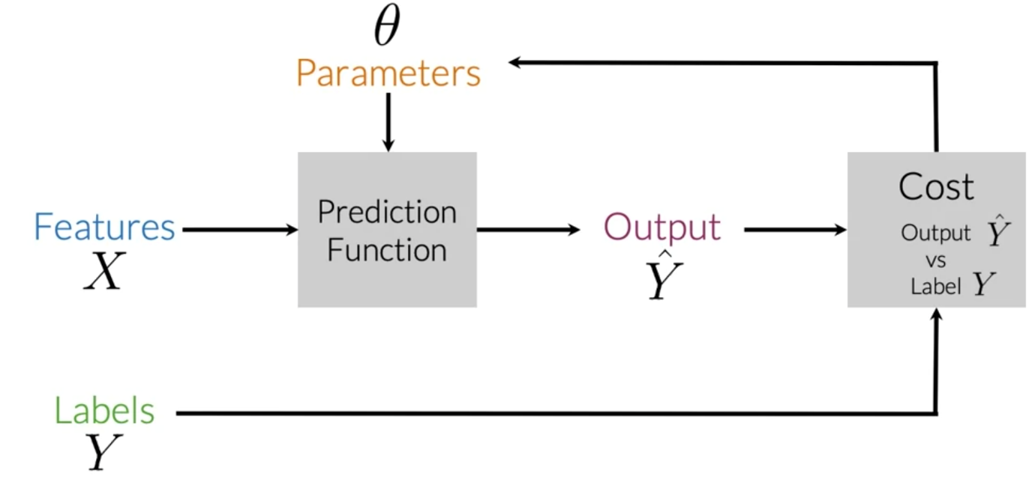

To perform sentiment analysis on a tweet, you first have to represent the text (i.e. "I am happy because I am learning NLP ") as features, you then train your **logistic regression classifier**, and then you can use it to classify the text.

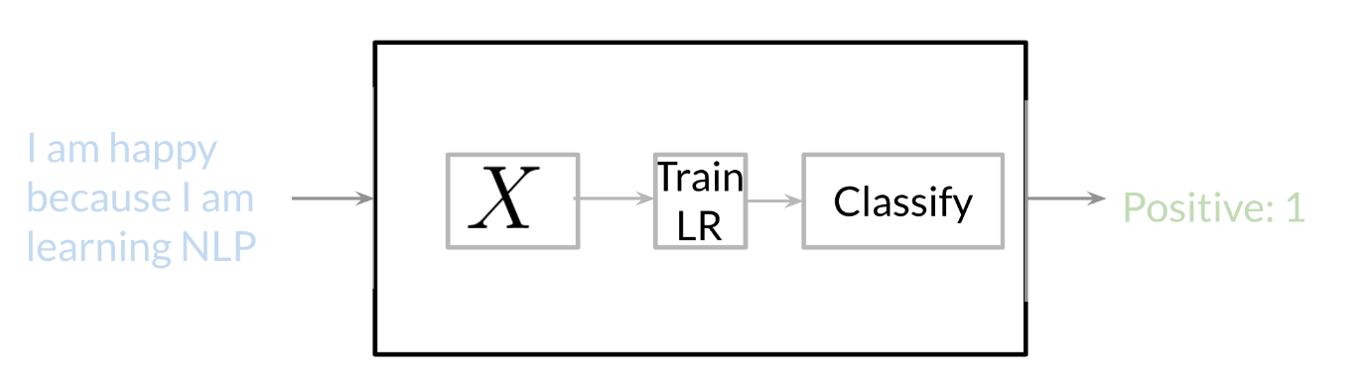

Note that in this case, you either classify 1, for a positive sentiment, or 0, for a negative sentiment.

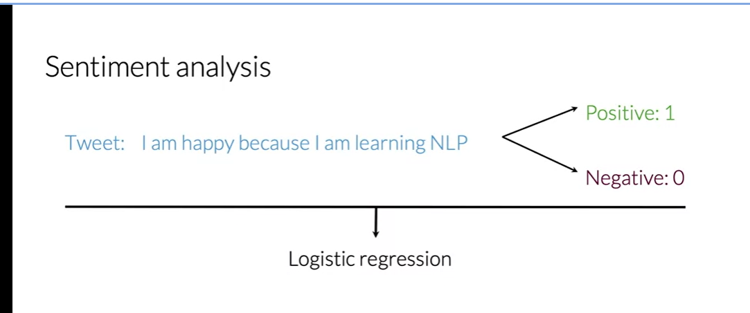

**REPRESENT TEXT AS A VECTOR**

In order for you to do so, you first have to **build a vocabulary** and that will allow you to

encode any text or any tweet as an array of numbers.

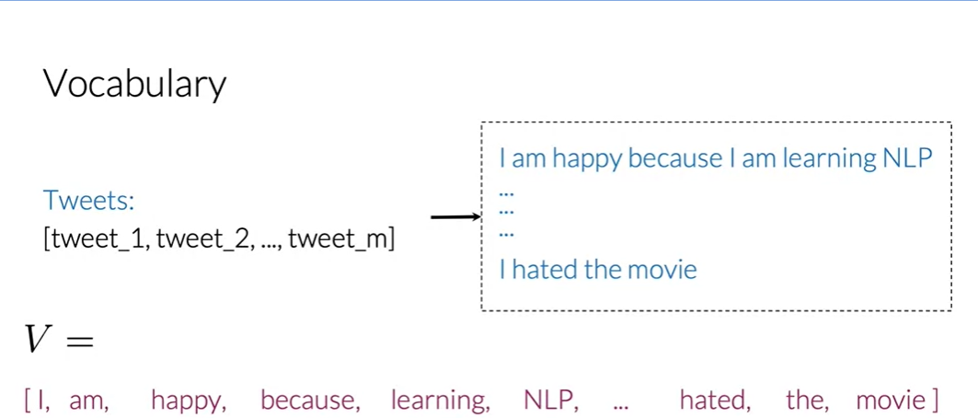

Vocabulary, V, would be the list of unique words from your list of tweets.

To get that list, you'll have to go through all the words from all your tweets and save

every new word that appears in your search.

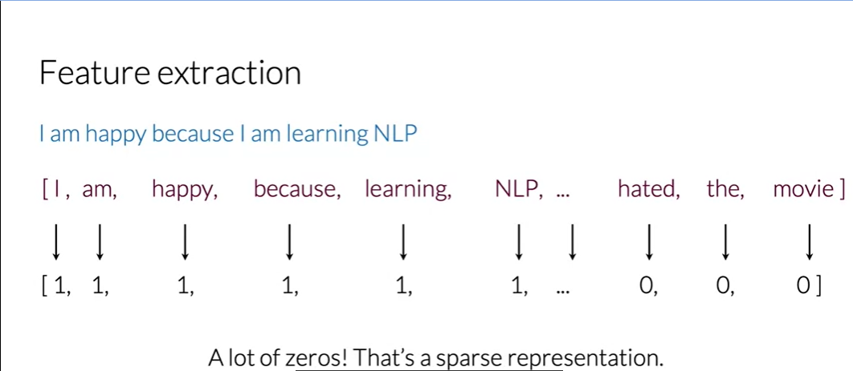

To do feature extraction, we have to check if every word from our vocabulary appears in the tweet. If it does appear, you would assign a value of 1 to that feature.  If it doesn't appear, you'd assign a value of 0.

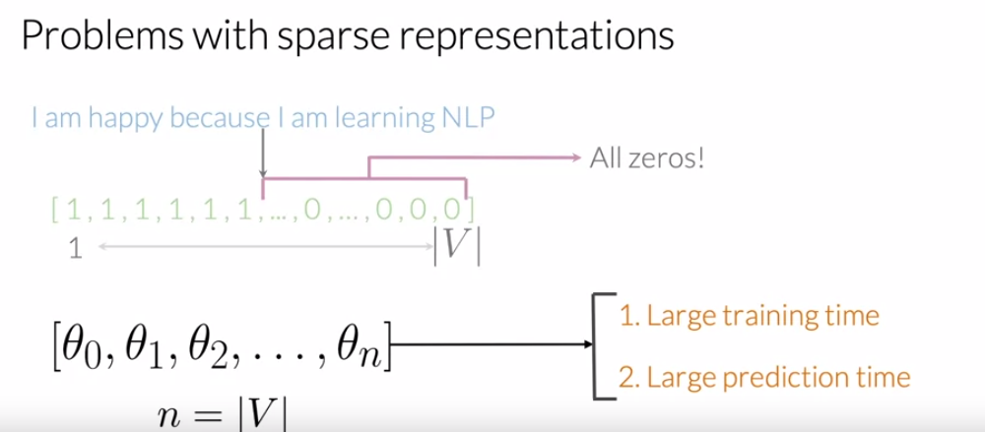

**GENERATE COUNTS**

Given a word, we want to keep track of the number of times, that's where it shows up as the positive class.

Given another word we want to keep track of the number of times that word showed up in the negative class.

Using both those counts, we can then extract features and use those features into your logistic regression classifier.

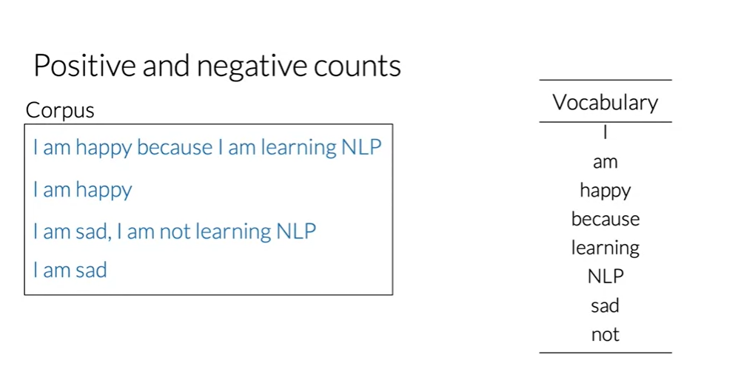

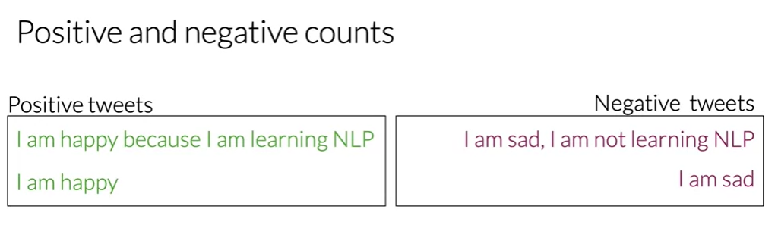

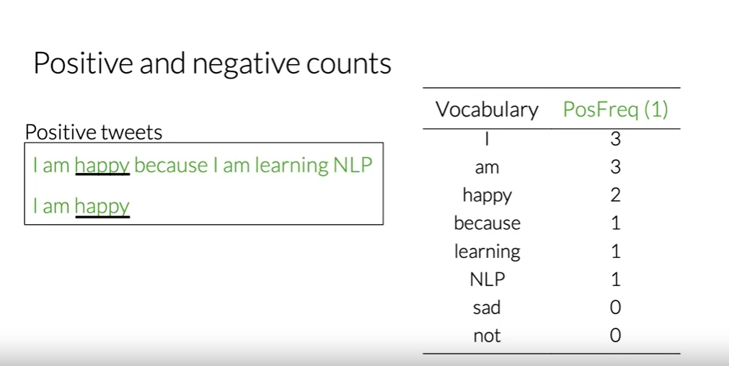

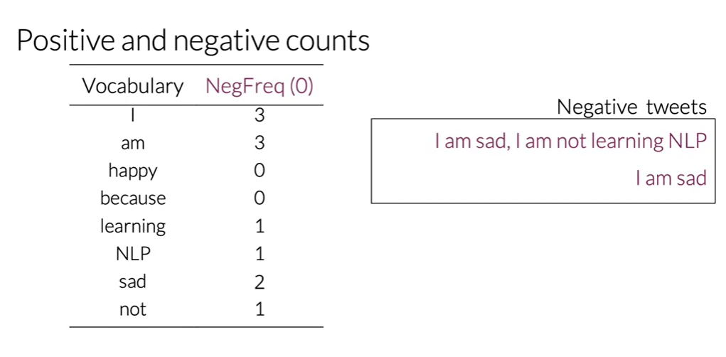

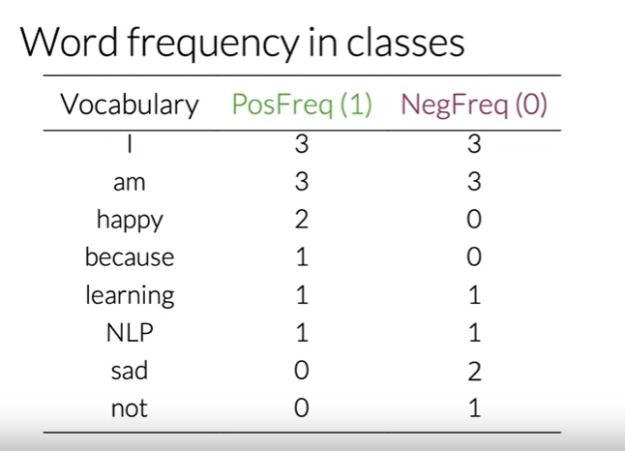

This is the entire table with the positive and negative frequencies for your corpus.

In practice when coding, this table is a dictionary mapping from a word class there to its frequency.

So, it maps the word and its corresponding class to the frequency or the number of

times that's where it showed up in the class.

You now know how to create a frequency dictionary, which maps a word and the class to

the number of times that word showed up in the corresponding class.

**FREQUENCY DICTIONARY TO REPRESENT A TWEET**

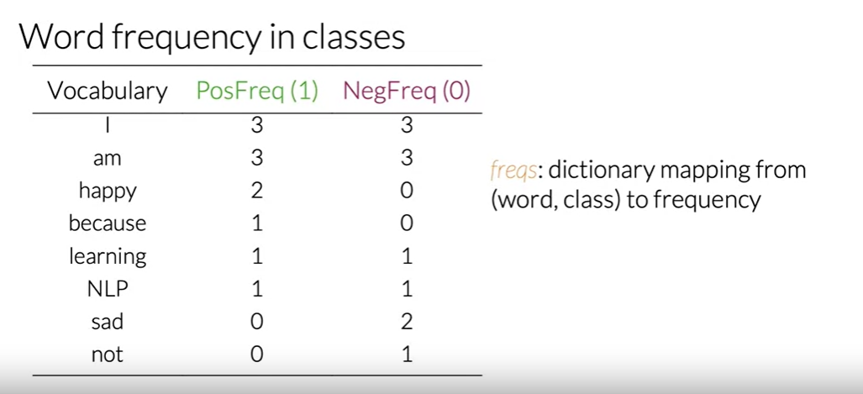

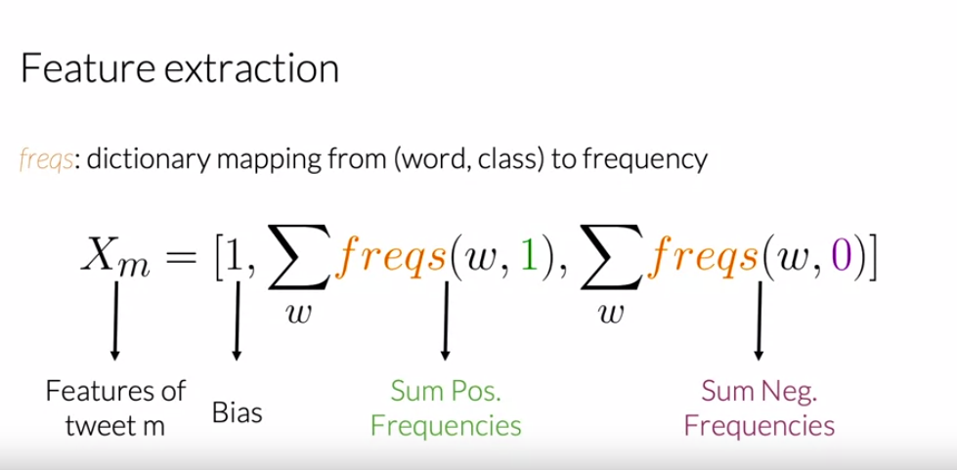

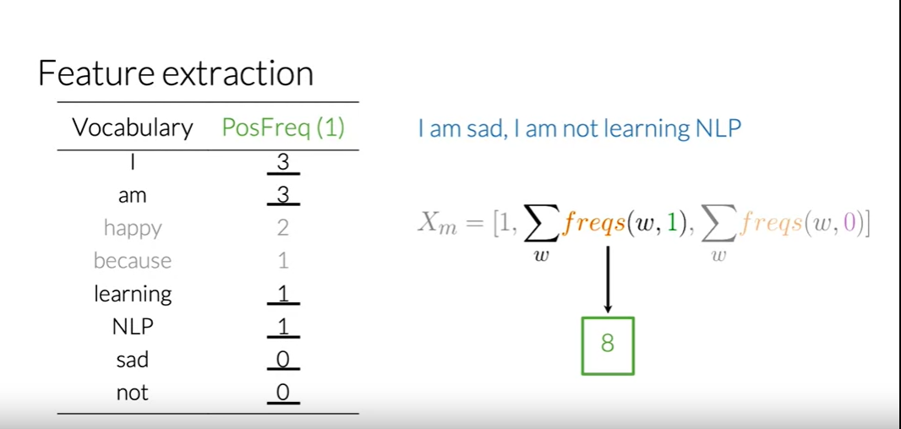

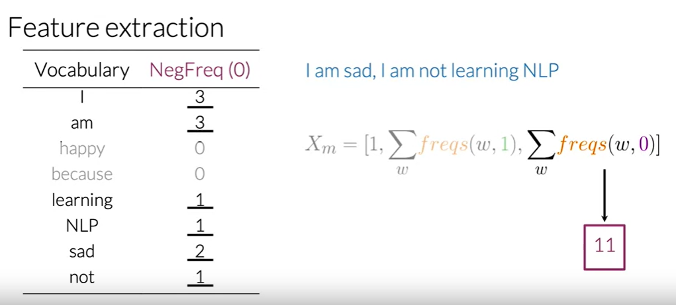

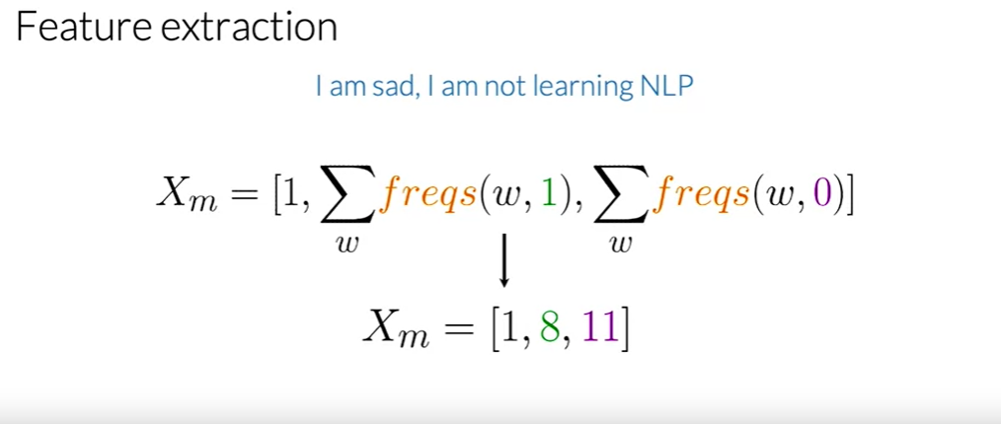

**Feature Extraction with Frequencies**

Given a corpus with positive and negative tweets as follows:

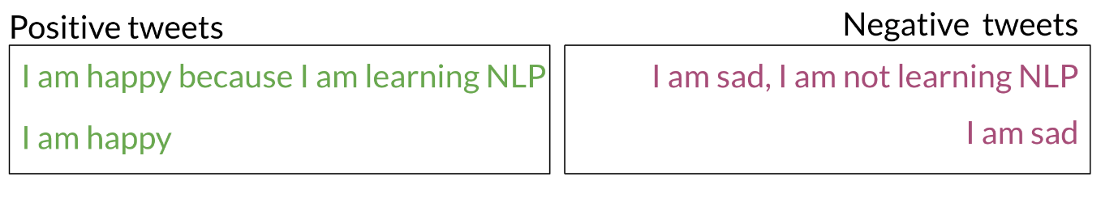

You have to encode each tweet as a vector. Previously, this vector was of dimension *V*. Now, as you will see in the upcoming videos, you will represent it with a vector of dimension 3. To do so, you have to create a dictionary to map the word, and the class it appeared in (positive or negative) to the number of times that word appeared in its corresponding class.

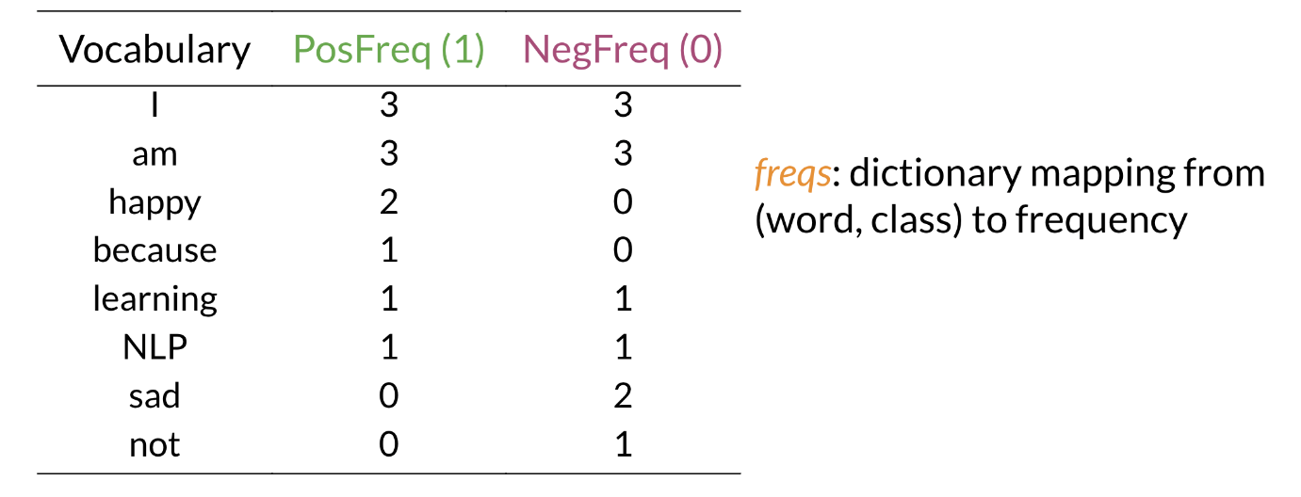

In the past two videos, we call this dictionary `freqs`. In the table above, you can see how words like happy and sad tend to take clear sides, while other words like "I, am" tend to be more neutral. Given this dictionary and the tweet, "I am sad, I am not learning NLP", you can create a vector corresponding to the feature as follows:

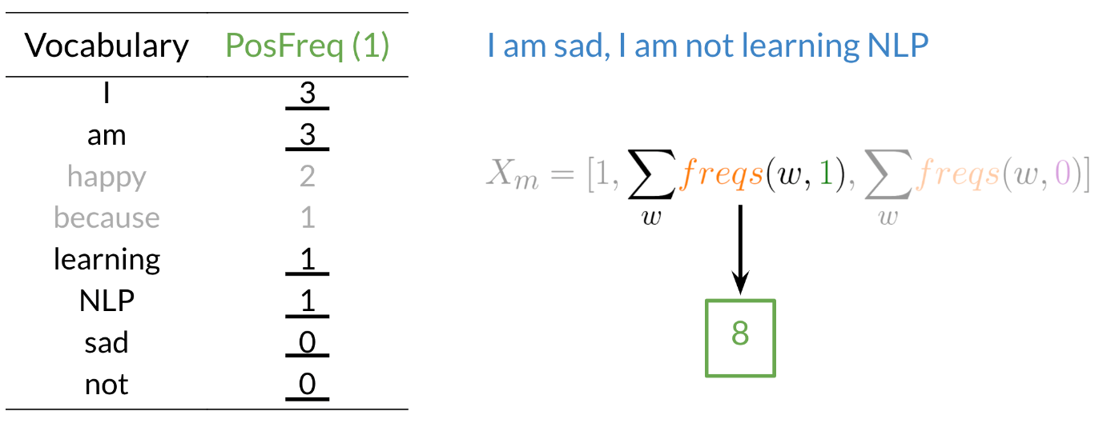

To encode the negative feature, you can do the same thing.

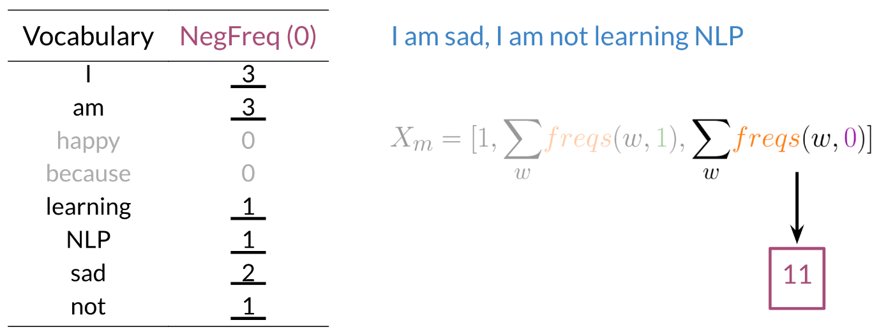

Hence you end up getting the following feature vector [1,8,11]. 1 corresponds to the bias, 8 the positive feature, and 11 the negative feature.

**PREPROCESSING**

2 major concepts:

Stemming

Stop words

Remove all the words that don't add significant meaning to the tweets, aka stop words and punctuation marks.

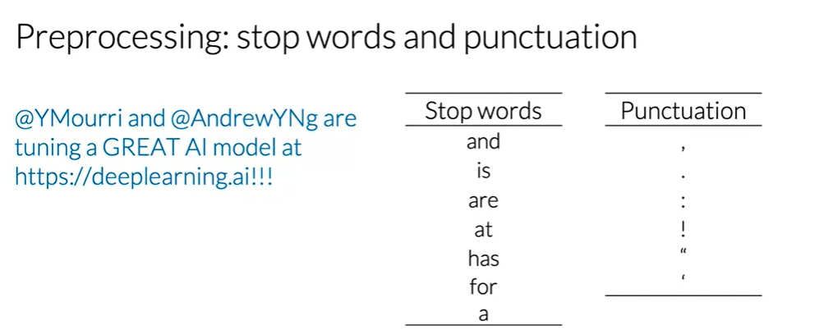

Every word from the tweet that also appears on the list of stop words should be eliminated.

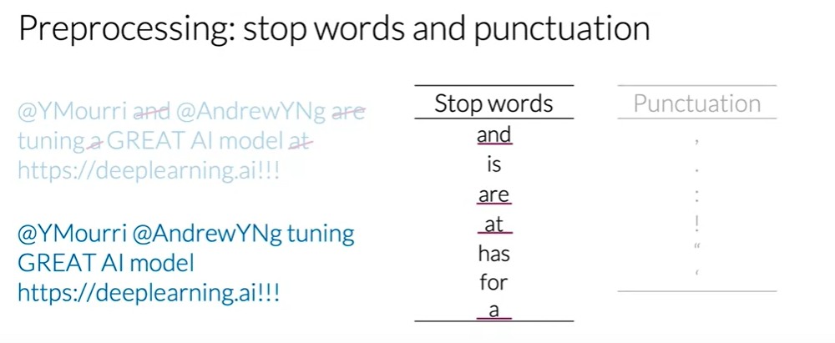

 let's eliminate every punctuation mark.

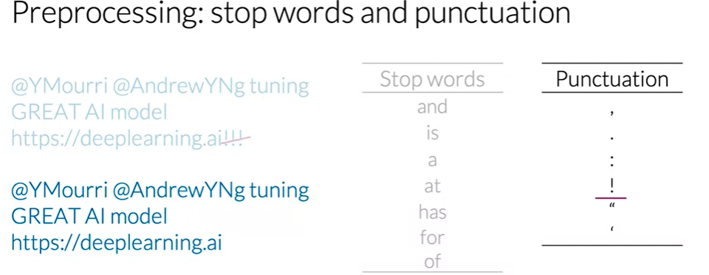

Tweets and other types of texts often have handles and URLs, but these don't add any value for

the task of sentiment analysis.

Let's eliminate these two handles and this URL.

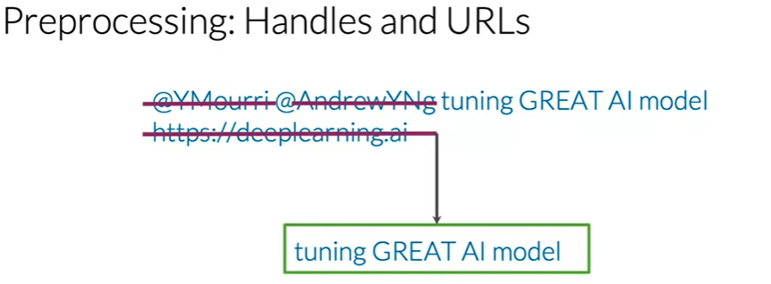

**Stemming** in NLP is simply transforming any word to its base stem, which you could define as the set of characters that are used to construct the word and its derivatives.

To reduce your vocabulary even further without losing valuable information, you'd have to lowercase every one of your words.

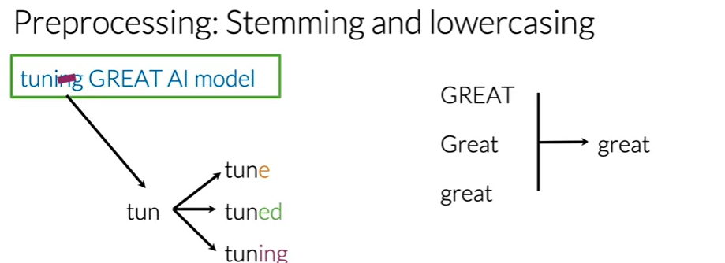

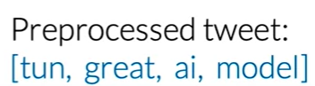

Hence you can see how we eliminated handles, tokenized it into words, removed stop words, performed stemming, and converted everything to lower case.

NOTE:

When preprocessing, you have to perform the following:

1. Eliminate handles and URLs
2. Tokenize the string into words.
3. Remove stop words like "and, is, a, on, etc."
4. Stemming- or convert every word to its stem. Like dancer, dancing, danced, becomes 'danc'. You can use porter stemmer to take care of this.
5. Convert all your words to lower case.

PRE-PROCESSING OF TWEETS

Imort nltk

# module for stop words that come with NLTK

from nltk.corpus import stopwords

# module for stemming

from nltk.stem import PorterStemmer

# module for tokenizing strings

from nltk.tokenize import TweetTokenizer

# library for regular expression operations

import re

# for string operations

import string

# download the stopwords from NLTK

nltk.download('stopwords')

#re.sub(): function from the re (regular expression) module

# used for performing regular expression-based substitutions in a string

# remove old style retweet text "RT"

tweet2 = re.sub(r'^RT[\s]+', '', tweet)

#r'^RT[\s]+': regular expression pattern that specifies what we want to find and replace in the tweet text:

    # ^: This symbol anchors the pattern to the beginning of the string. ensures that "RT" is only matched if it appears at the start of the text.

    # RT: This is the literal text "RT" that we want to find and remove.

    # [\s]+: This part of the pattern matches one or more whitespace characters (spaces or tabs) following the "RT" text. used to account for the potential presence of spaces after "RT."

#'': replacement string. it's an empty string '', which means that any text that matches the pattern specified in the regular expression will be replaced with nothing, effectively removing it.

# it searches for instances of "RT" at the beginning of the tweet text followed by one or more whitespace characters and replaces those instances with an empty string.

# This operation effectively removes the retweet indicator ("RT") from the tweet text.

# remove hyperlinks

tweet2 = re.sub(r'https?://[^\s\n\r]+', '', tweet2)

#r'https?://[^\s\n\r]+': This is the regular expression pattern that specifies what we want to find and replace in tweet2:

    #https?://: This part of the pattern matches URLs starting with "http://" or "https://". The s? part makes the "s" character optional, so it matches both "http://" and "https://".

    #[^\s\n\r]+: This part of the pattern matches one or more characters that are not whitespace (\s), newline (\n), or carriage return (\r). In other words, it matches the actual URL characters.

# remove hashtags

# only removing the hash # sign from the word

tweet2 = re.sub(r'#', '', tweet2)

tokenizer = TweetTokenizer(preserve_case=False, strip_handles=True,

                               reduce_len=True)

#preserve_case: specifies whether the tokenizer should preserve the case (uppercase and lowercase letters) of the tokens in the tweet. False means convert everything into lowercase

#strip_handles=True: Twitter usernames, often referred to as handles, start with the "@" symbol.

#Setting strip_handles to True tells the tokenizer to remove Twitter handles from the tweet.

#reduce_len=True: Tokenizer should reduce the length of repeated characters in words.

# For example, words like "cooool" might be tokenized as "cool" to normalize the text. Setting reduce_len to True enables this feature.

# tokenize tweets

tweet_tokens = tokenizer.tokenize(tweet2)

stopwords_english = stopwords.words('english')

for word in tweet_tokens: # Go through every word in your tokens list

    if (word not in stopwords_english and  # remove stopwords

        word not in string.punctuation):  # remove punctuation

        tweets_clean.append(word)

# Instantiate stemming class

stemmer = PorterStemmer()

# Create an empty list to store the stems

tweets_stem = []

for word in tweets_clean:

    stem_word = stemmer.stem(word)  # stemming word

    tweets_stem.append(stem_word)  # append to the list

VISUALIZING WORD FREQUENCIES

# select some words to appear in the report. we will assume that each word is unique (i.e. no duplicates)

keys = ['happi', 'merri', 'nice', 'good', 'bad', 'sad', 'mad', 'best', 'pretti',

        '❤', ':)', ':(', '😒', '😬', '😄', '😍', '♛',

        'song', 'idea', 'power', 'play', 'magnific']

# list representing our table of word counts.

# each element consist of a sublist with this pattern: [<word>, <positive_count>, <negative_count>]

data = []

# loop through our selected words

for word in keys:

    # initialize positive and negative counts

    pos = 0

    neg = 0

    # retrieve number of positive counts

    if (word, 1) in freqs:

        pos = freqs[(word, 1)]

    # retrieve number of negative counts

    if (word, 0) in freqs:

        neg = freqs[(word, 0)]

    # append the word counts to the table

    data.append([word, pos, neg])

The build_freqs is the function for creating word frequencies:

def build_freqs(tweets, ys):

    """Build frequencies.

    Input:

        tweets: a list of tweets

        ys: an m x 1 array with the sentiment label of each tweet

            (either 0 or 1)

    Output:

        freqs: a dictionary mapping each (word, sentiment) pair to its

        frequency

    """

    # Convert np array to list since zip needs an iterable.

    # The squeeze is necessary or the list ends up with one element.

    # Also note that this is just a NOP if ys is already a list.

    yslist = np.squeeze(ys).tolist()

    # Start with an empty dictionary and populate it by looping over all tweets

    # and over all processed words in each tweet.

    freqs = {}

    for y, tweet in zip(yslist, tweets):

        for word in process_tweet(tweet):

            pair = (word, y)

            if pair in freqs:

                freqs[pair] += 1

            else:

                freqs[pair] = 1

    return freqs

Output for this is ('followfriday', 1.0): 25. This is one of the elements of the dictionary.

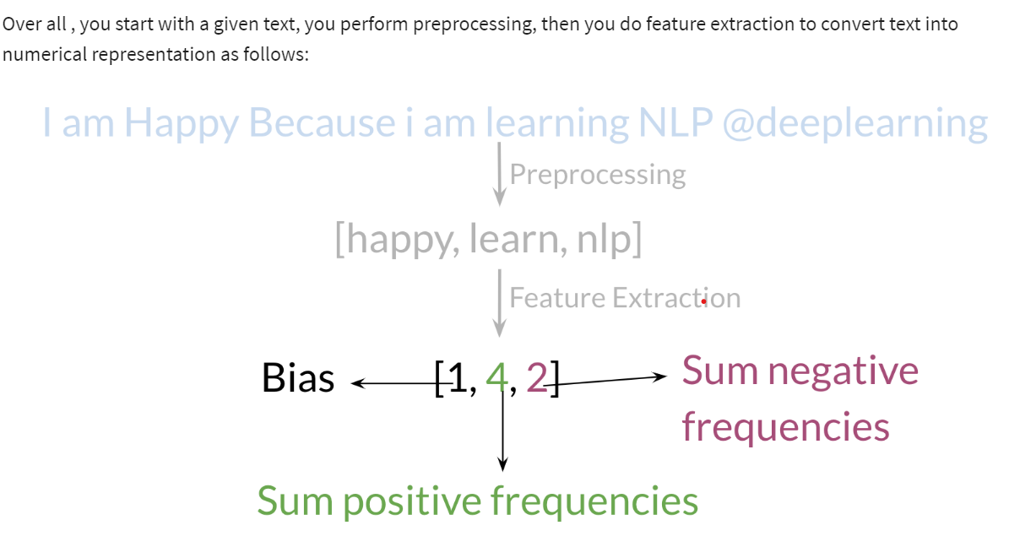

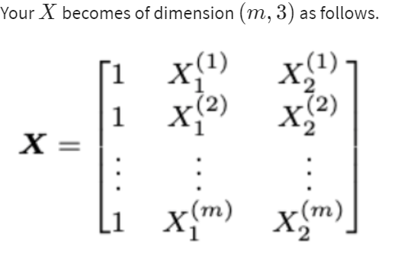

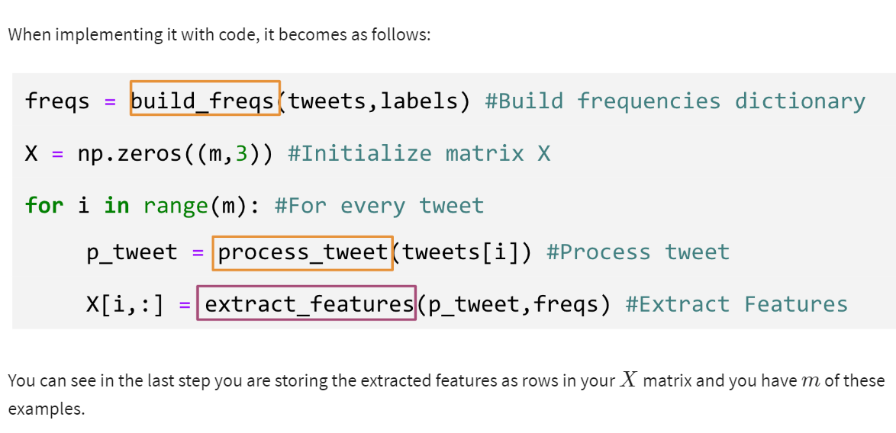

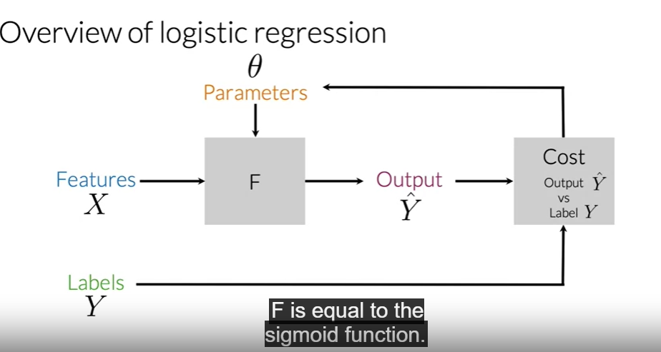

For logistic regression, F is a sigmoid function.

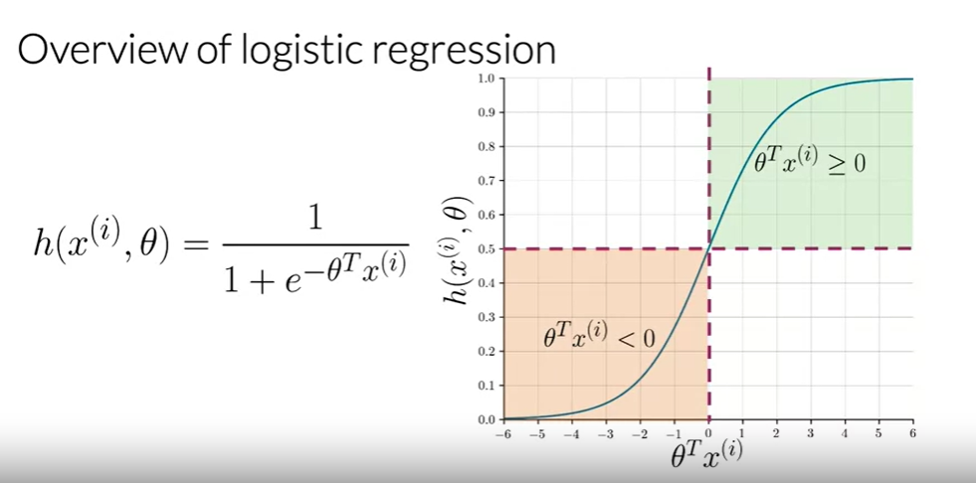

Logistic regression makes use of a sigmoid function which outputs a probability between zero and one.

The function used to classify in logistic regression H is the sigmoid function and it depends on the parameters Theta and then the features vector X superscripts i, where i is used to denote

the ith observation or data points.

Visually, the sigmoid function has this form and it approaches zero as the dot product of Theta transpose X, approaches minus infinity and one as it approaches infinity.

For classification, a threshold is needed. Usually, it is set to be 0.5 and this value corresponds to

a dot product between Theta transpose and X equal to zero. So whenever the dot product is

greater or equal than zero, the prediction is positive, and whenever the dot product is less than zero, the prediction is negative.

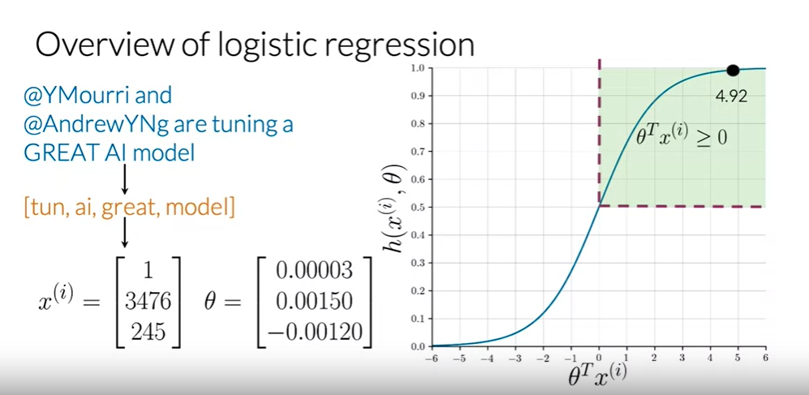

So let's look at an example in the now familiar context of tweets and sentiment analysis.

Look at the following tweet. After a preprocessing, you should end up with a list like this.

Note that handles are deleted, everything is in lowercase and the word tuning is reduced to its stem, tun. Then you would be able to extract features given a frequencies dictionary and arrive at a vector similar to the following.

With a bias units over here and two features that are the sum of positive and negative frequencies of all the words in your processed tweets. Now assuming that you already have

an optimum sets of parameters Theta, you would be able to get the value of the sigmoid function, in this case, equal to 4.92, and finally, predict a positive sentiment.

Now that you know the notation for logistic regression, you can use it to train a weight factor Theta.

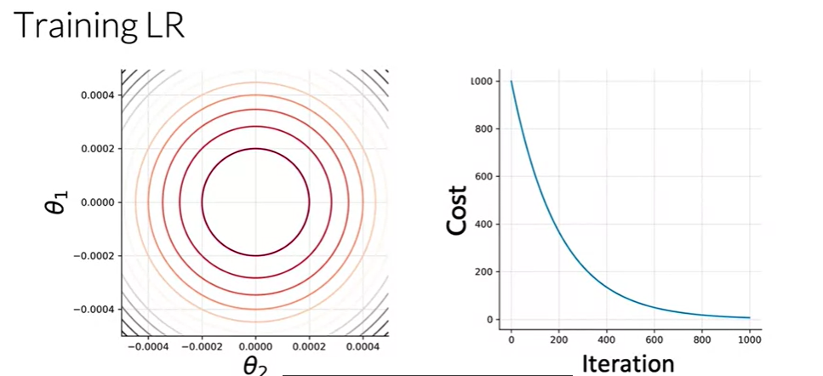

Let us suppose that your loss only depends on the parameters theta1 and theta2, you would have a cost function that looks like this contour plots on the left.

On the right, you can see the evolution of the cost function as you iterate.

First, you would have to initialize your parameters theta.

Then you will update your theta in the direction of the gradient of your cost function.

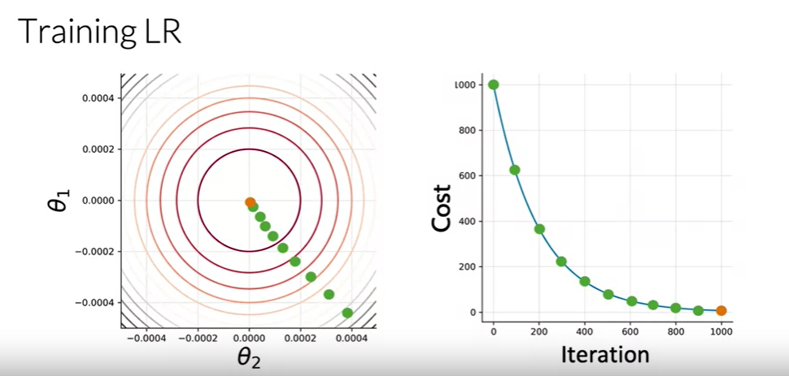

After a 100 iterations, you would be at this point, after 200 here, and so on. After many iterations, you derive to a point near your optimum costs and you'd end your training here.

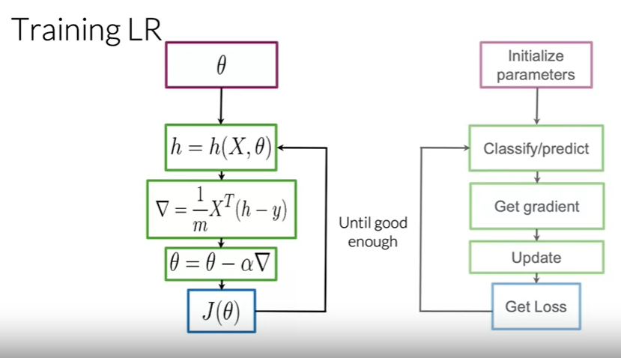

Let's look at this process in more detail.

First, you'd have to initialize your parameters vector theta. Then you'd use the logistic function

to get values for each of your observations. After that, you'd be able to calculate the gradients

of your cost function and update your parameters. Finally, you'd be able to compute your cost J and determine if more iterations are needed according to a stop-parameter or maximum number of iterations.

This algorithm is known as **gradient descent**.

Now, that you have your theta variable, you want to evaluate your theta, meaning you want to evaluate your classifier. Once you put in your theta into your sigmoid function, do get a good classifier or do you get a bad classifier?

TESTING LOGISTIC REGRESSION

To test your model, you would run a subset of your data, known as the validation set, on your model to get predictions. The predictions are the outputs of the sigmoid function. If the output is ≥=0.5≥=0.5, you would assign it to a positive class. Otherwise, you would assign it to a negative class.

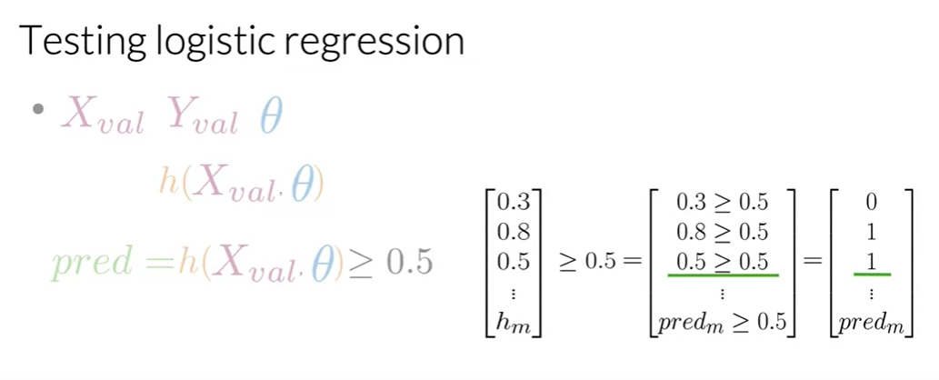

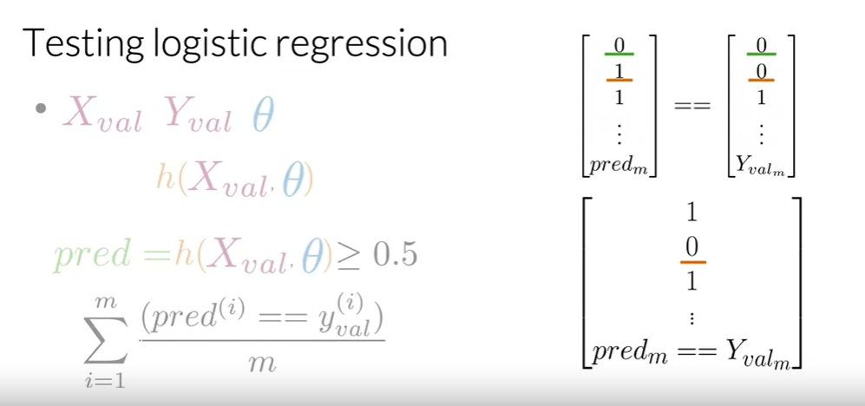

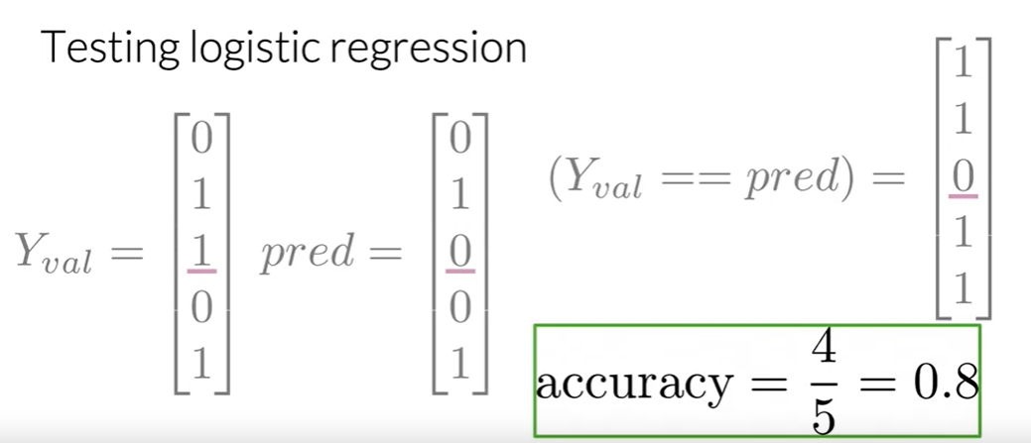

COST FUNCTION

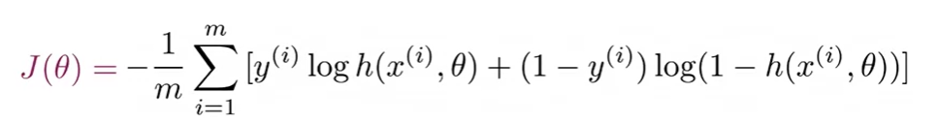

m- number of training examples in your training set

The minus sign ensures that your overall costs will always be a positive number

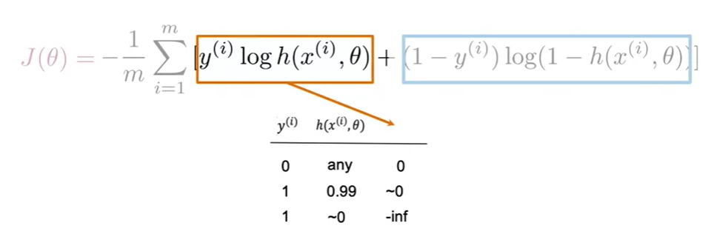

The term on the left is the product of y superscript i, which is the label for each training example, multiplied by the log of the prediction, which is the logistic regression function applied to each training example. Represented as h of superscript i, and a parameter theta.

If your label is 1, and your prediction is close to 0, then this term blows up and approaches negative infinity.

Intuitively, now, you can see that this is the relevant term in your cost function

when your label is 1. When your prediction is close to the label value, the loss is small,

and when your label and prediction disagree, the overall cost goes up.

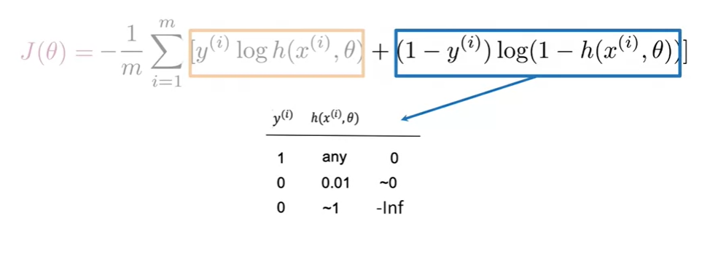

Consider the term on the right hand side of the cost function equation, in this case, if your label is 1, then the 1- y term goes to 0. And so any value returned by the logistic regression function will result in a 0 for the entire term, because again, 0 times anything is just 0. If your label is 0, and the logistic regression function returns a value close to 0, then the products in this term will again be close to 0. If on the other hand your label is 0 and your prediction is close to 1, then the log term will blow up and the overall term will approach to negative infinity.

There is one term in the cost funcxtion that is relevant when your label is 0, and another that is relevant when the label is 1. In each of these terms, you're taking the log of a value between 0 and 1, which will always return a negative number, and so the minus sign out front ensures that the overall cost will always be a positive number.

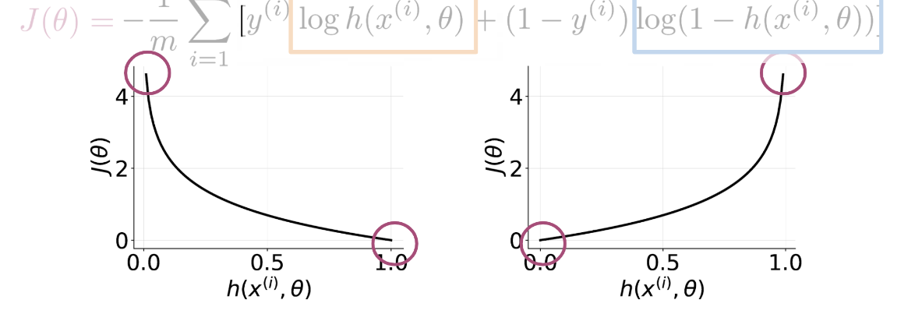

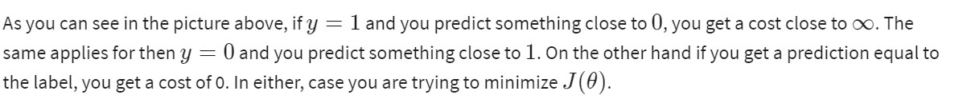

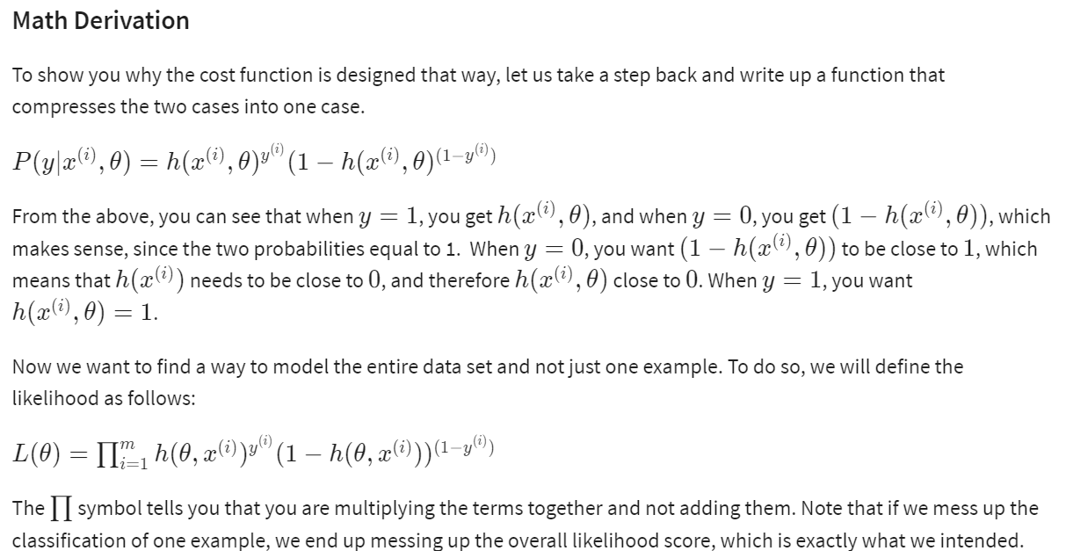

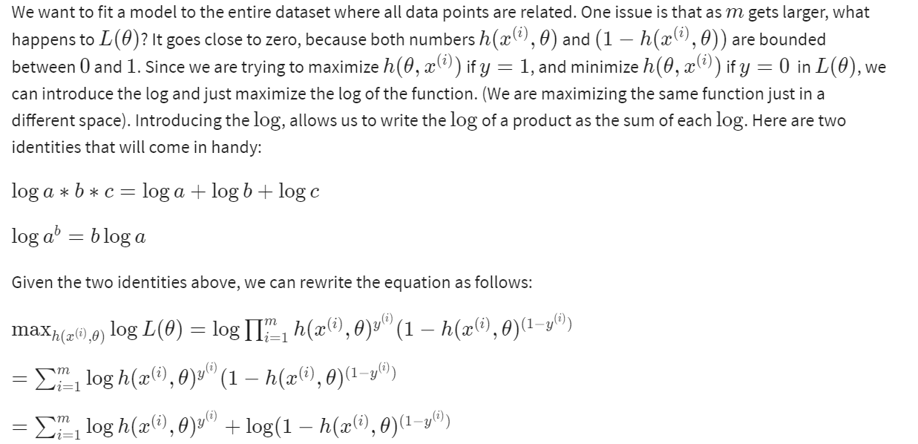

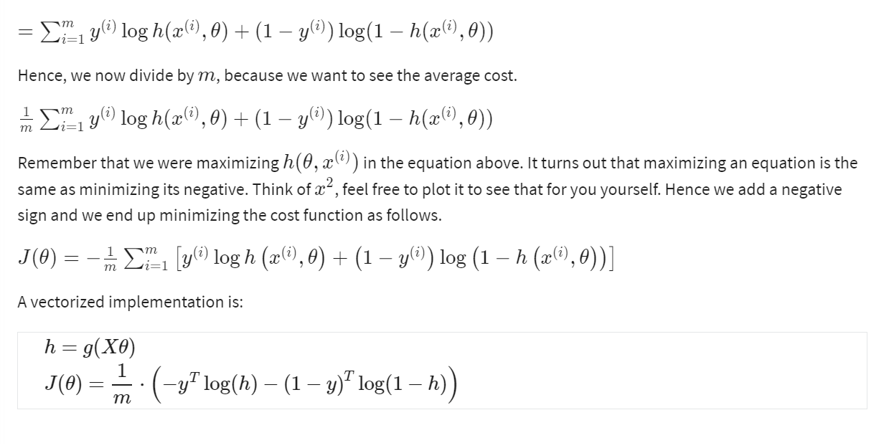

WEEK 2

We will look into naive Baye’s algorithm.

**Probability and Baye’s Rule**

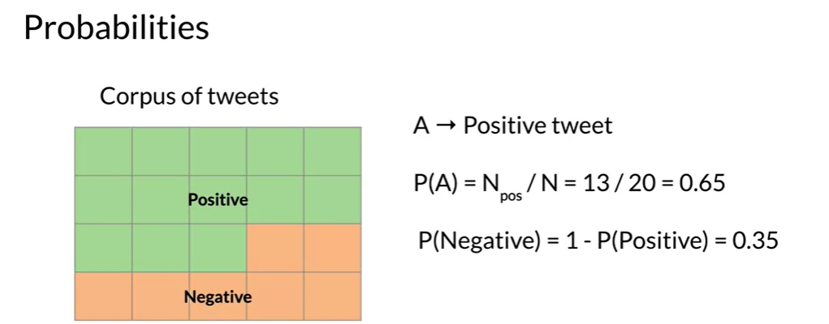

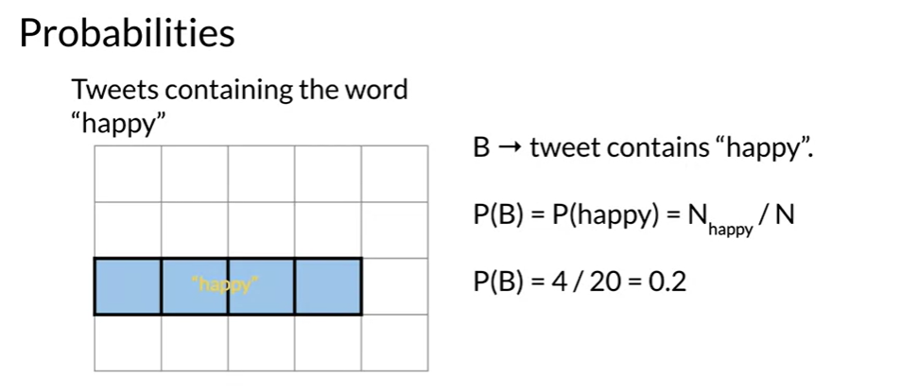

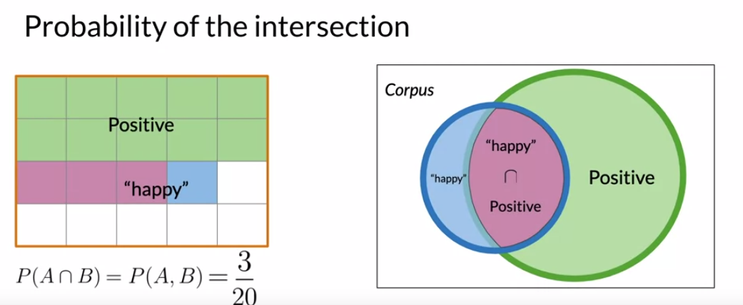

Conditional probabilities help us reduce the sample search space.

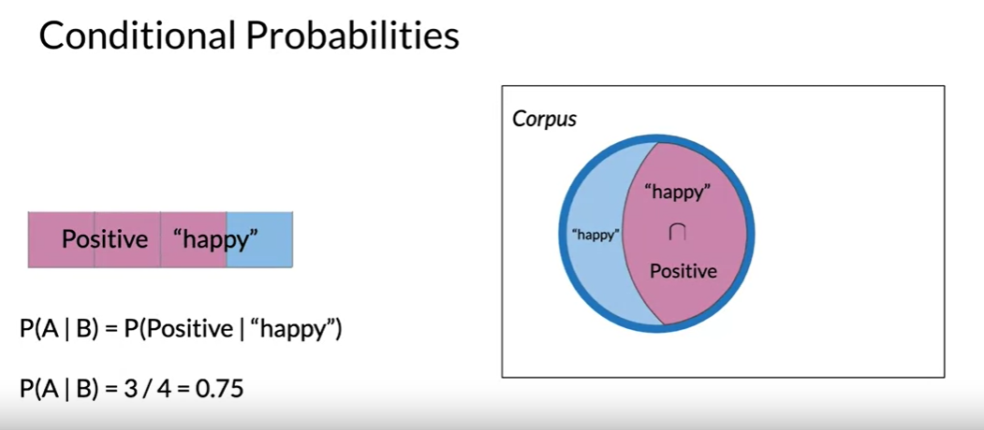

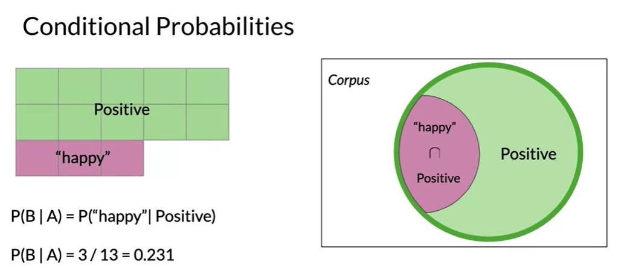

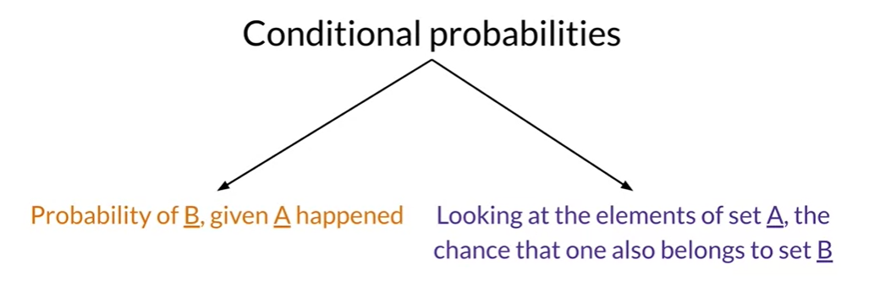

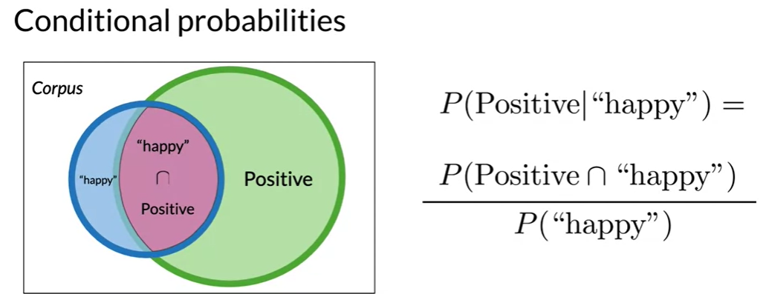

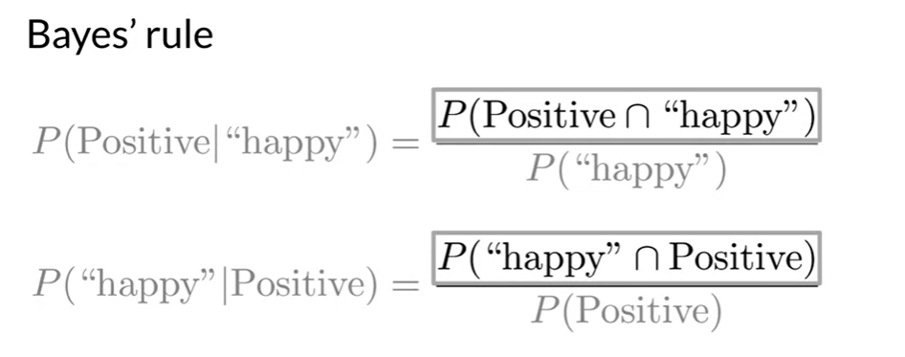

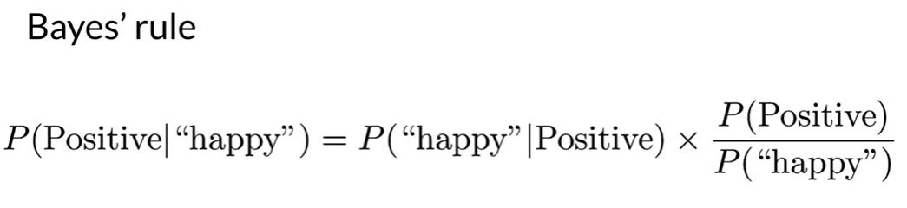

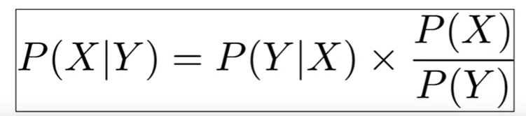

Naive Bayes is an example of supervised machine learning and shares many similarities with

the logistic regression method you used in the previous assignments.

It's called naive because this method makes the assumption that the features you're using for

classification are all independent, which in reality is rarely the case.

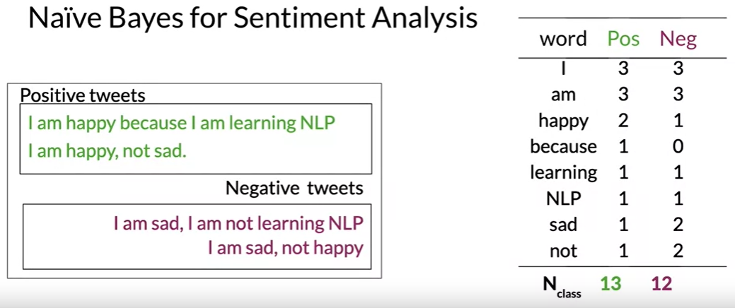

For positive tweets, there is a total of 13 words and for negative tweets, a total of 12 words.

This is the first new step for Naive Bayes and it's very important because it allows

you to compute the conditional probabilities of each word given the class.

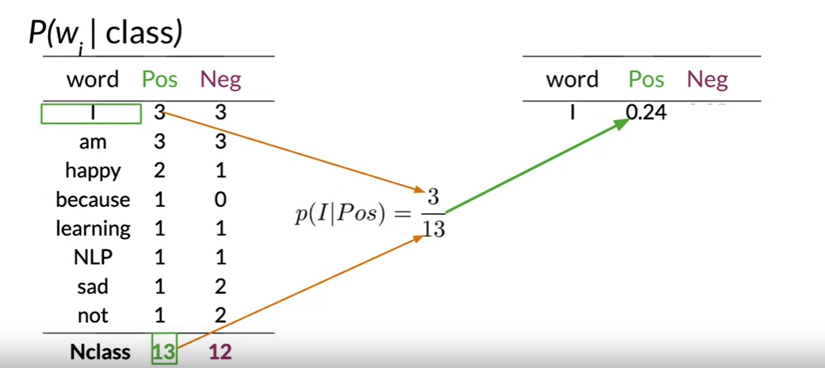

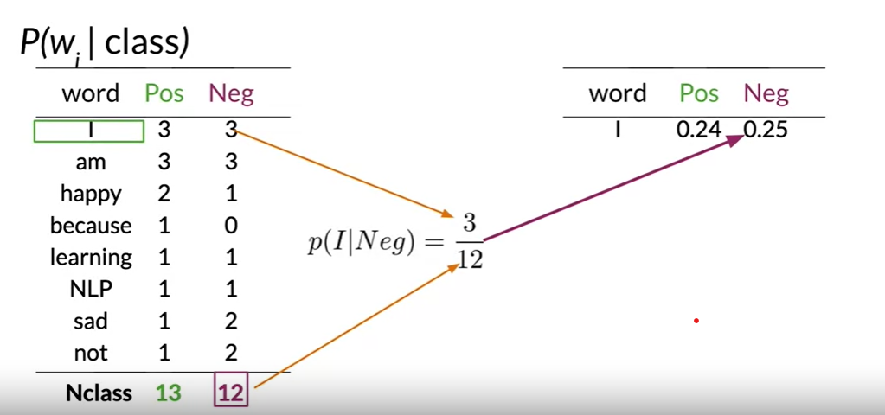

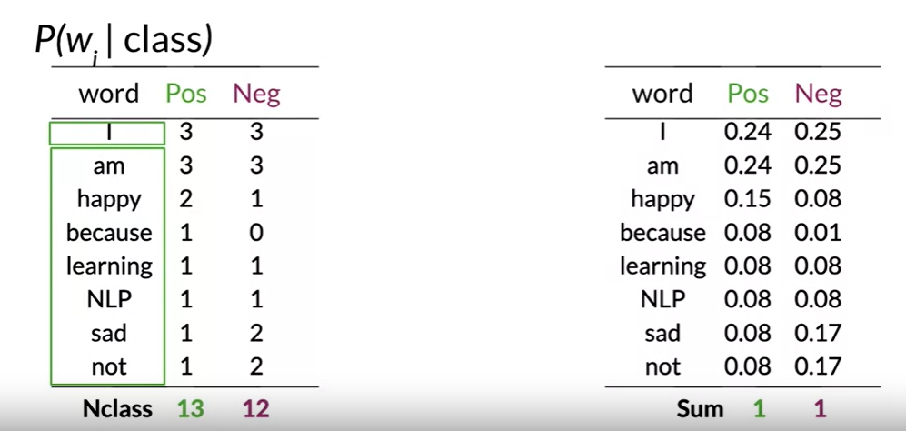

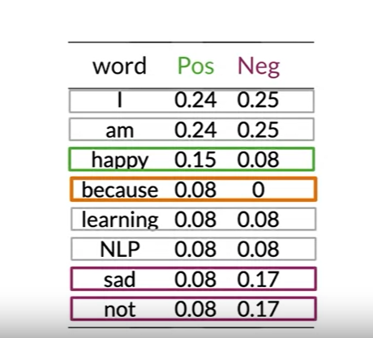

The interesting thing here is words that are equally probable don't add anything to the sentiment.

In contrast to these neutral words, other words like happy, sad, and not.

They have a significant difference between probabilities. These are your power words tending

to express one sentiment or the other. These words carry a lot of weight in determining your tweet sentiments.

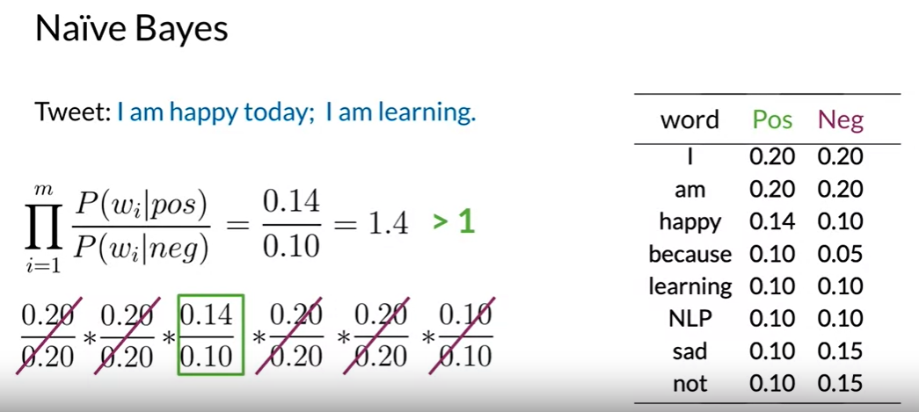

This value is higher than one, which means that overall, the words in the tweets are more likely

to correspond to a positive sentiment. So you conclude that the tweet is positive.

LAPLACIAN SOOTHING

Sometimes you try to calculate the probability of a word happening after a word.

To do that you might want to count the number of times those two words showed up. One after another, divided by the number of times the first word appeared. Now what if the two words never showed up next to each other in the training corpus. You get a probability of zero, and

the probability of an entire sequence might go to zero. Now how can we fix this problem? Let's take a look, let's now dive into Laplacian smoothing, a technique you can use to avoid your probabilities being zero.

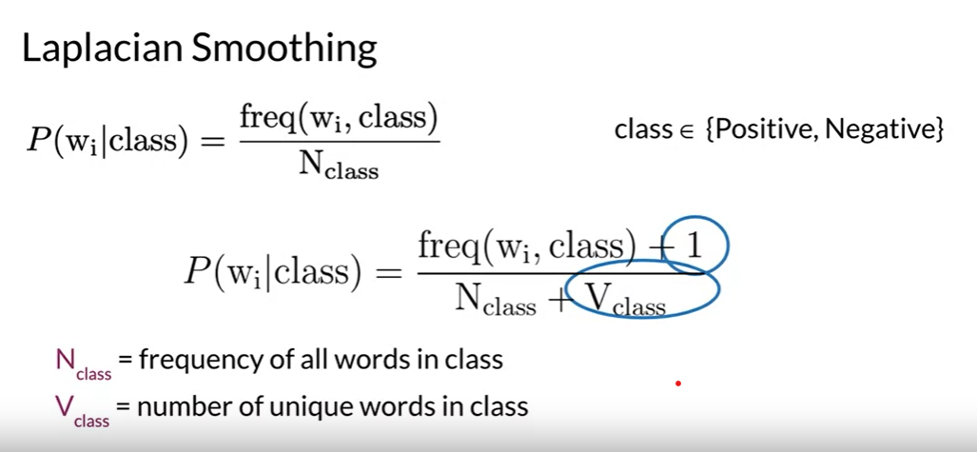



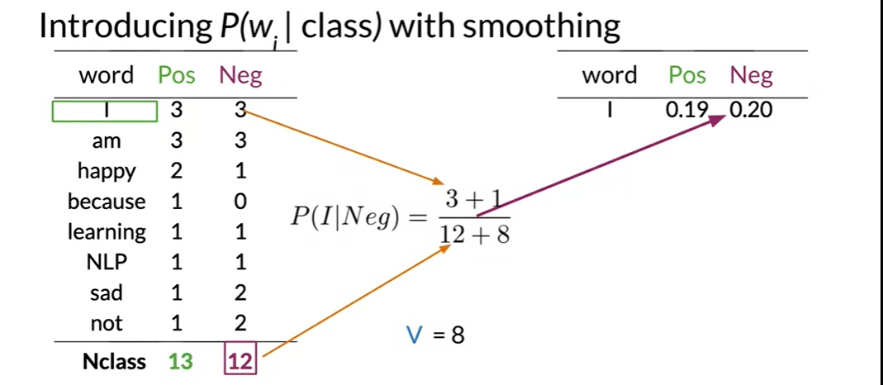

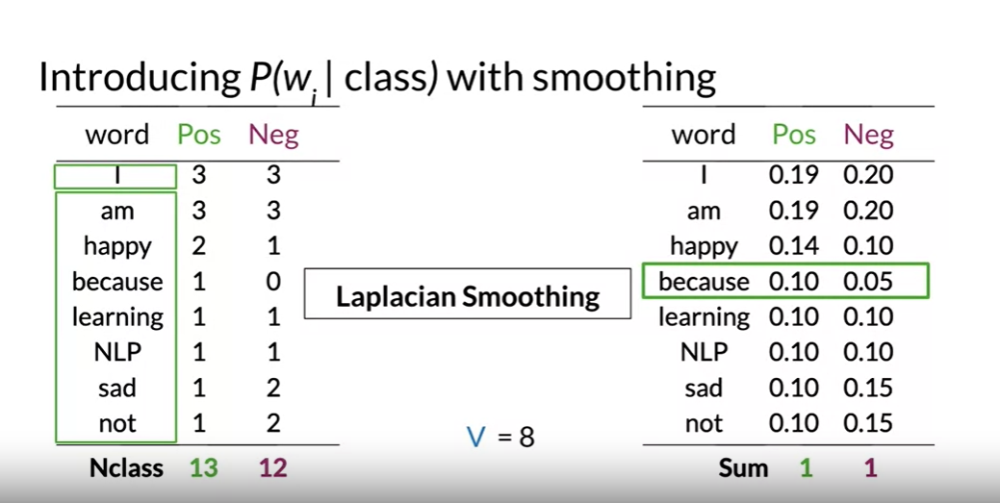

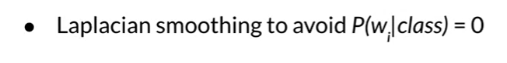

LOG LIKELIHOOD

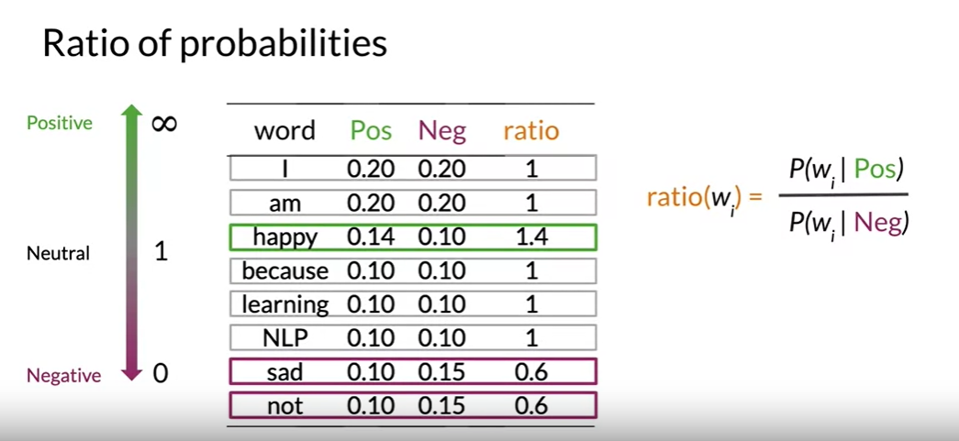

More the ratio means more the positive.

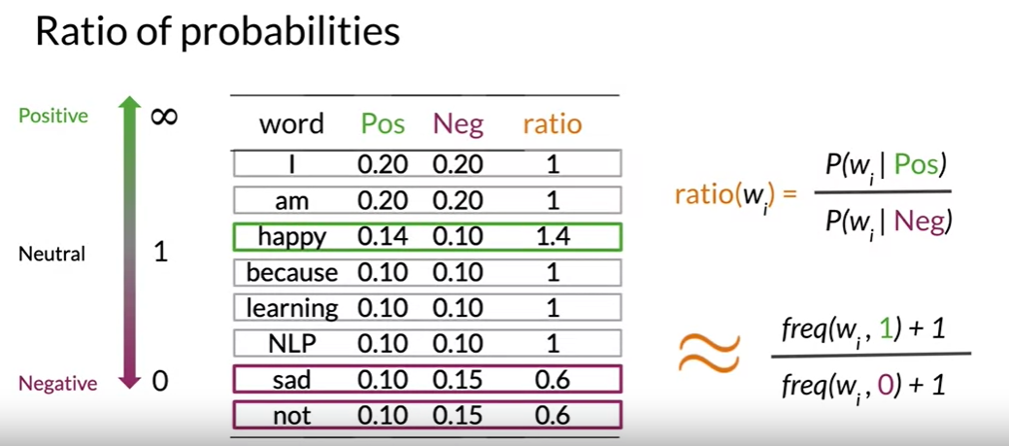

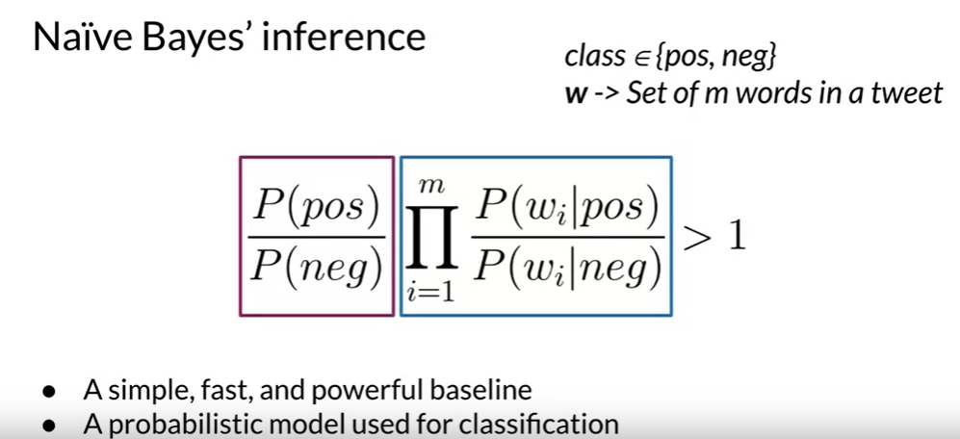

Recall earlier, where you use the formula to categorize a tweet as positive if the products of the corresponding ratios of every word appears in the tweet is bigger than 1.

We said it was negative, if it was less than 1. This is called the likelihood. If you were to take a ratio between the positive and negative tweets, you'd have what's called the prior ratio.

In this small example, you had exactly the same number of positive and negative tweets,

making the ratio 1.

In this week's assignments, you'll have a balanced data-sets, you'll be working with a ratio of 1.

In the future though, when you're building your own application, remember that this term becomes important for unbalanced data-sets. With the addition of the prior ratio, you now have the full Naive Bayes' formula for binary classification

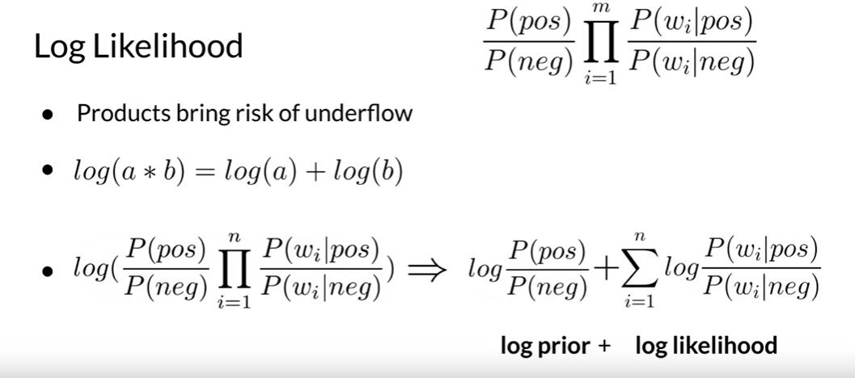

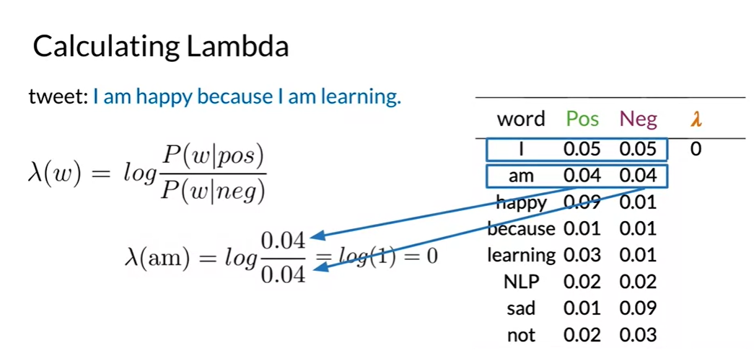

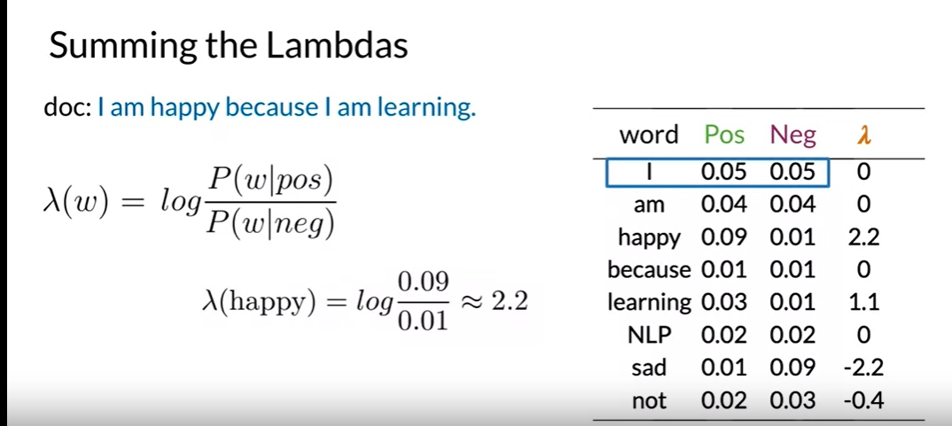

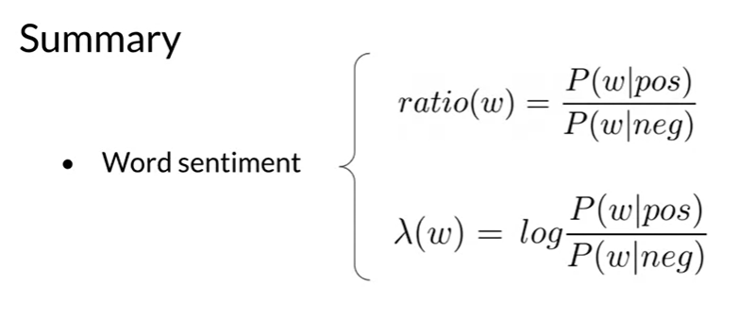

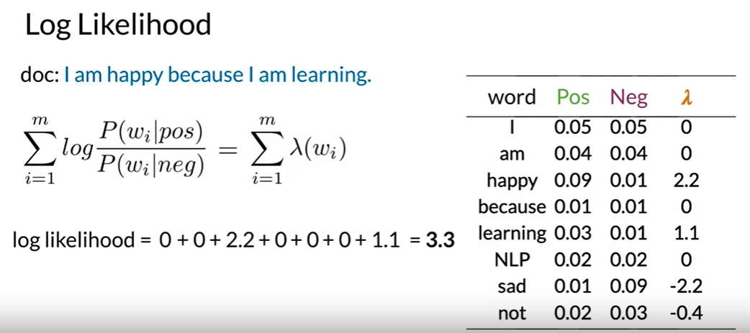

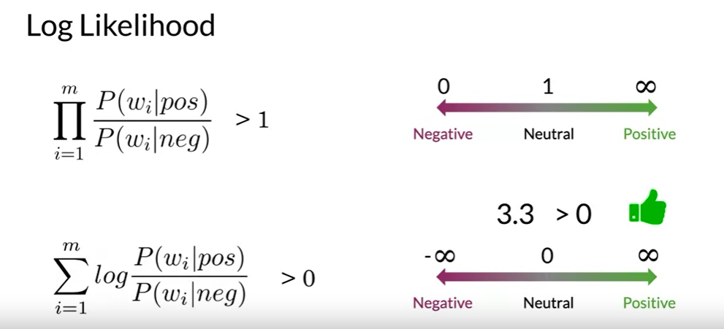

TRAINING NAÏVE BAYE’S CLASSIFIER

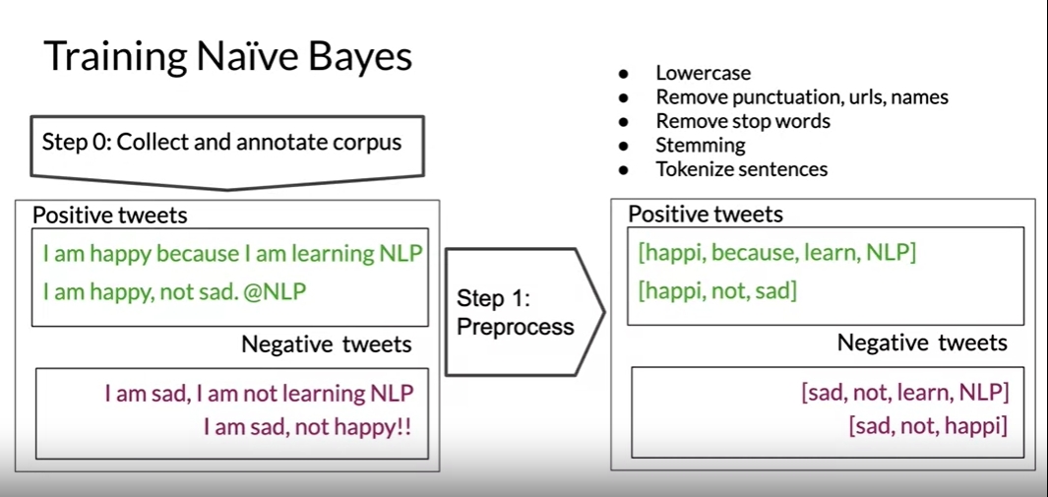

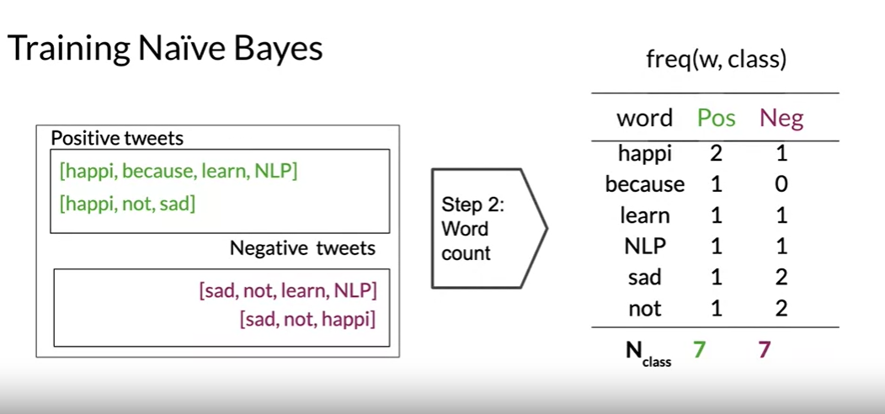

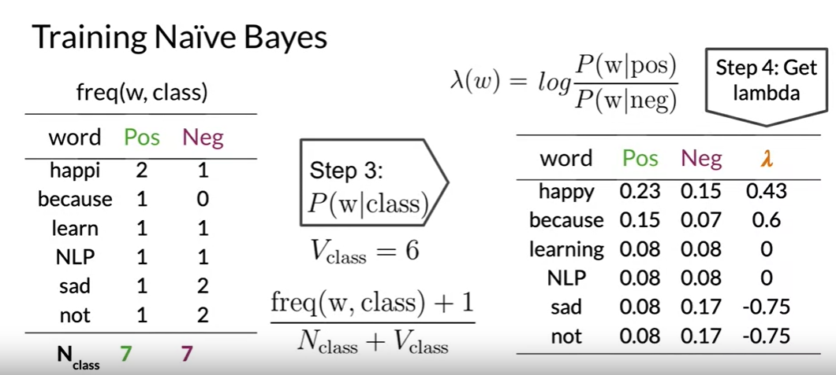

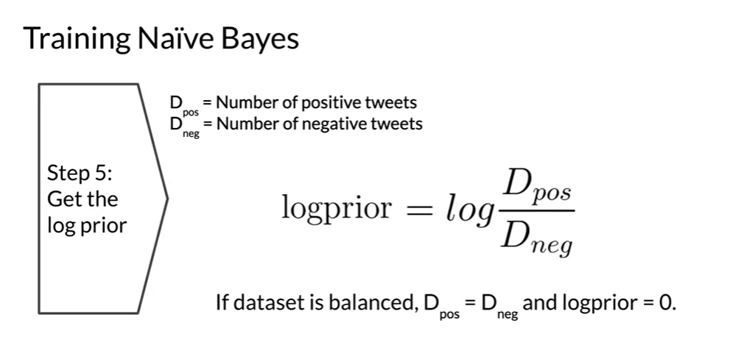

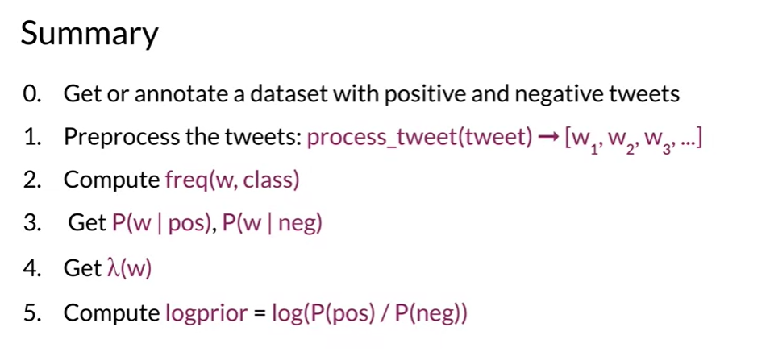

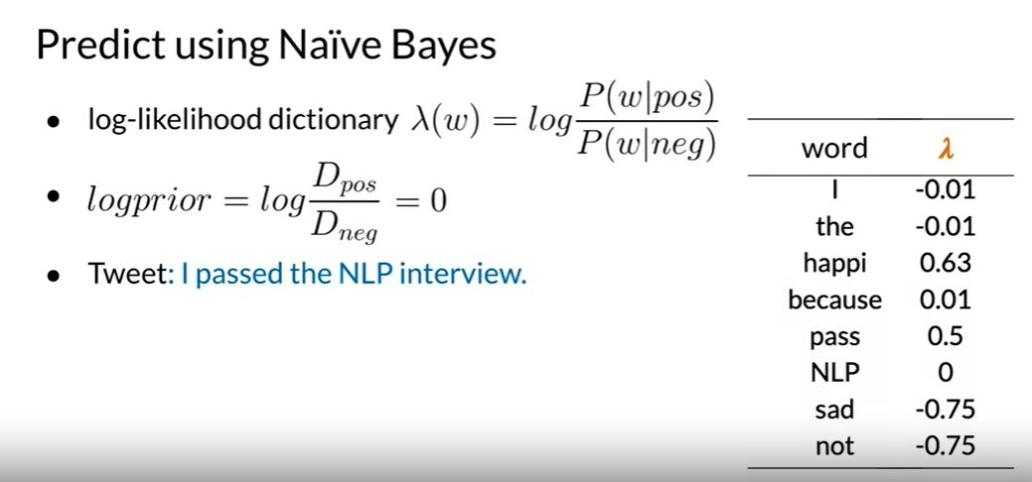

We must pre-process this text, removing the punctuation, stemming the words, and tokenizing to produce a vector of words.

Now, look up each word from the vector in your log-likelihood table.  If the word is found, such as I pass, the, and NLP, you sum over all the corresponding Lambda terms. The values that don't show up in the table of Lambdas, like interview, are considered neutral and don't contribute anything to the score.

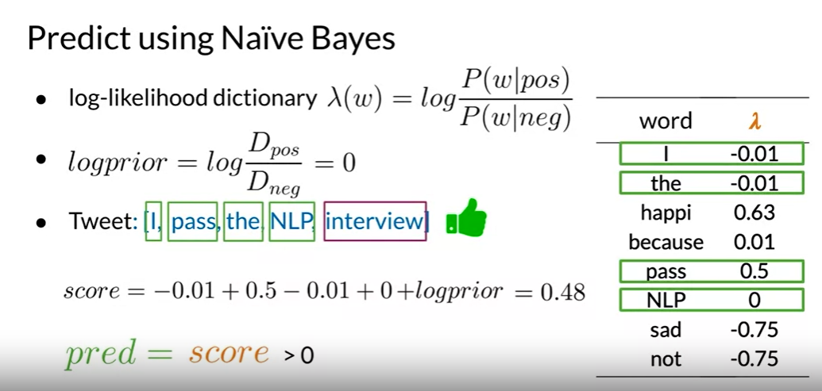

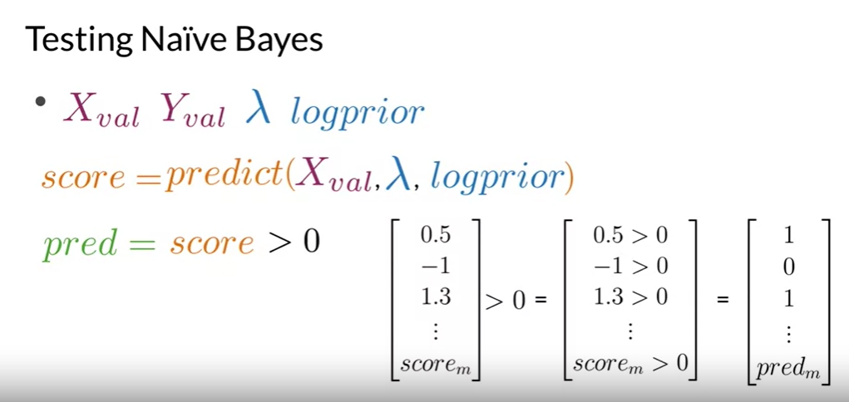

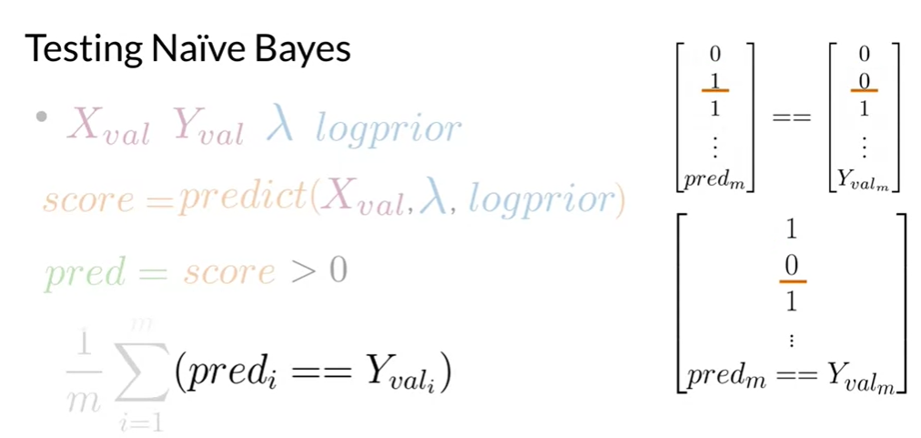

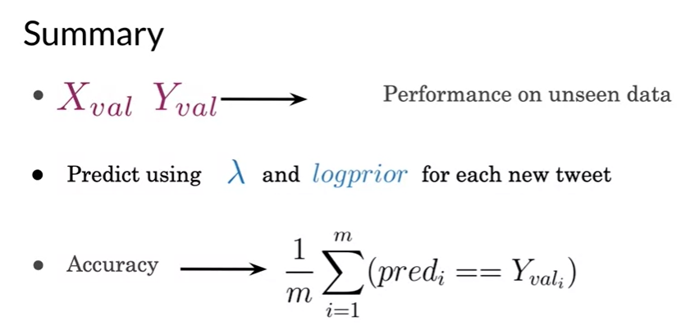

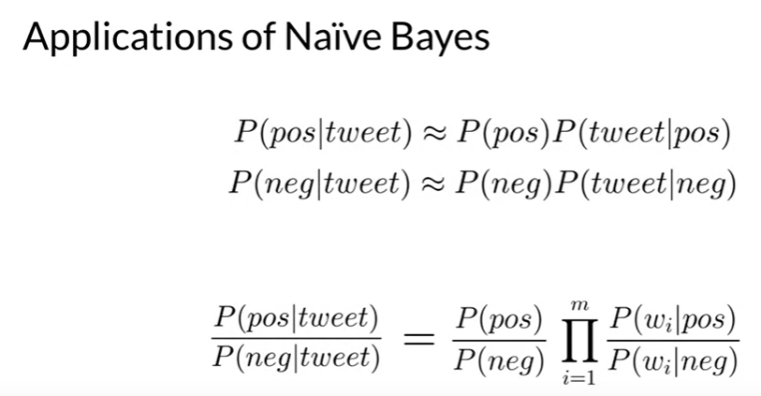

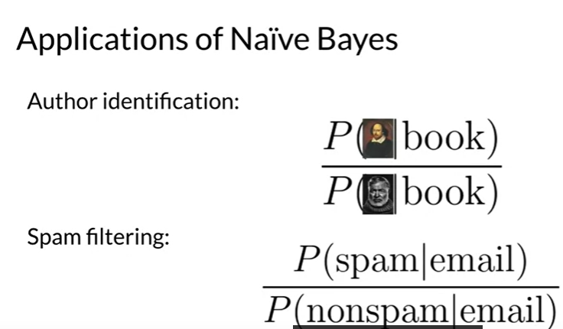

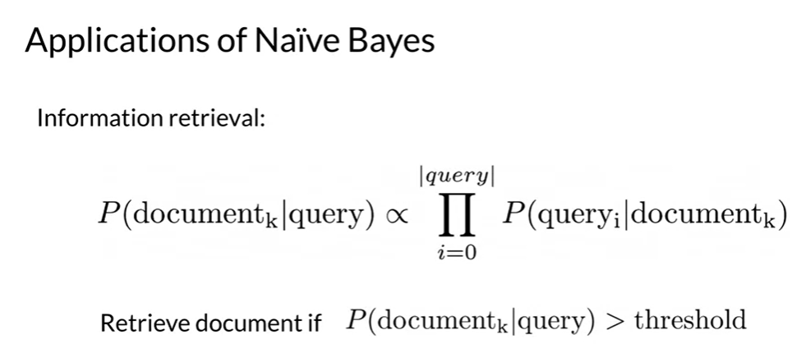

Filtering between relevant and irrelevant documents in a database given the sets of keywords in a query.

In this case, you only needed to calculate the likelihood of the documents given the query.

You can't know beforehand what's a relevant or irrelevant document looks like. You can compute the likelihood for each document in your dataset and then store the documents based on its likelihoods. You can choose to keep the first m results or the ones that have a likelihood larger than a certain threshold.

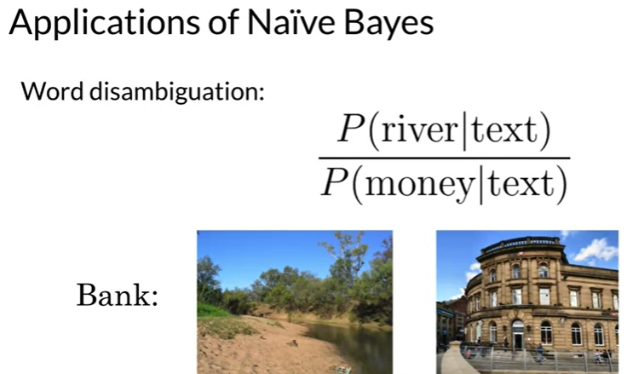

Word disambiguation, breaking down words for contextual clarity.

Consider that you have only two possible interpretations of a given word within a text.

Let's say you don't know if the word bank in your reading is referring to the bank of

a river or to a financial institution.

To disambiguate your word, calculate the score of the documents, given that it refers to each

one of the possible meanings. In this case, if the texts refers to the concept of river, instead of the concept of money, then the score will be bigger than

one.

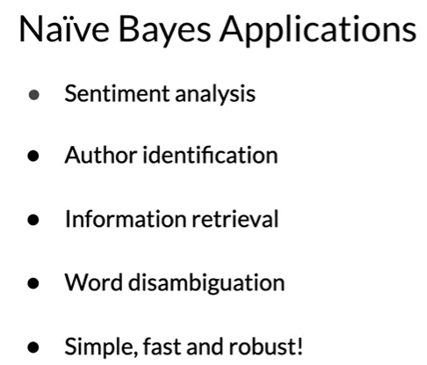

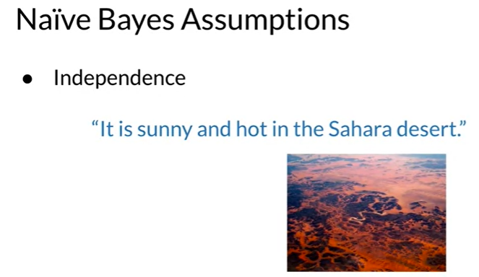

You can see the word sunny and hot tend to depend on each other and are correlated to a certain extent with the word "desert". Naive Bayes assumes independence throughout.

This could lead you to under or overestimate the conditional probabilities of individual words.

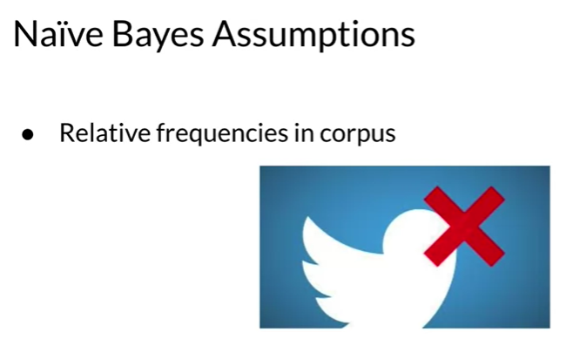

Could result in a very optimistic or very pessimistic model.

ERROR ANALYSIS

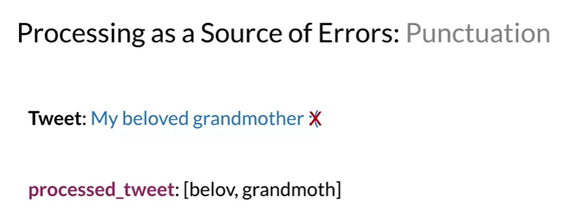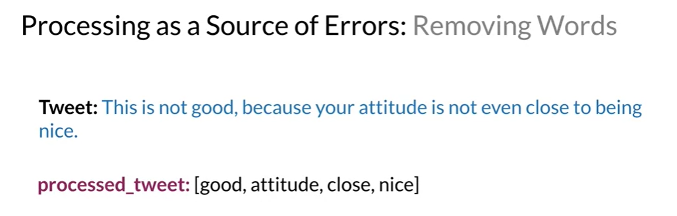

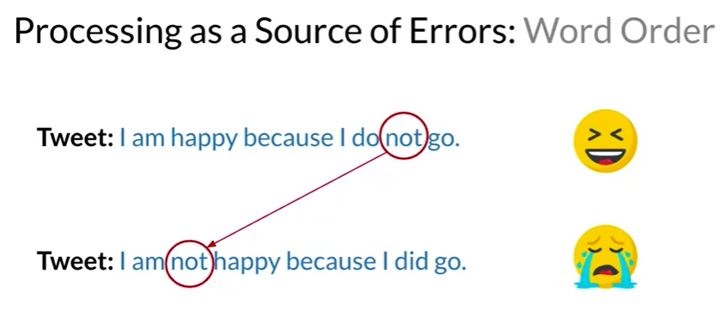

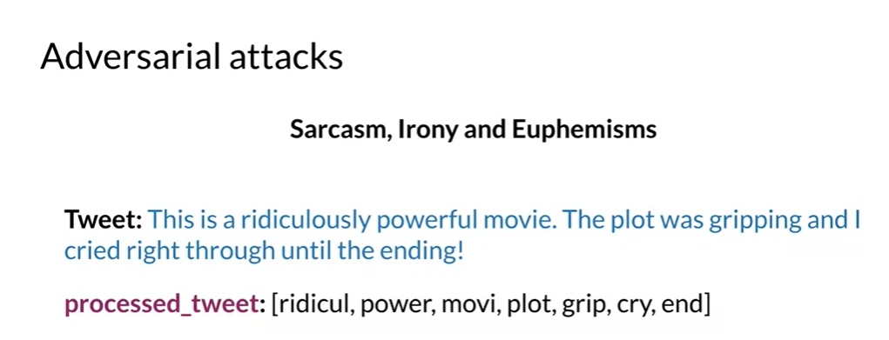

Note: To find transverse of array just use y.T

Note: To multiply 2 matrices x and y, x@y

WEEK 3- Word Vectors

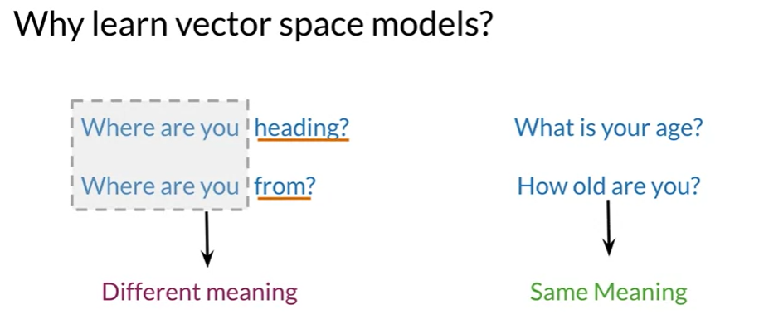

Vector space models will help you identify whether the first pair of questions or the second pair are similar in meaning even if they do not share the same words.

They can be used to identify similarity for a question answering, paraphrasing and summarization. Vector space models will also allow you to capture dependencies between words.

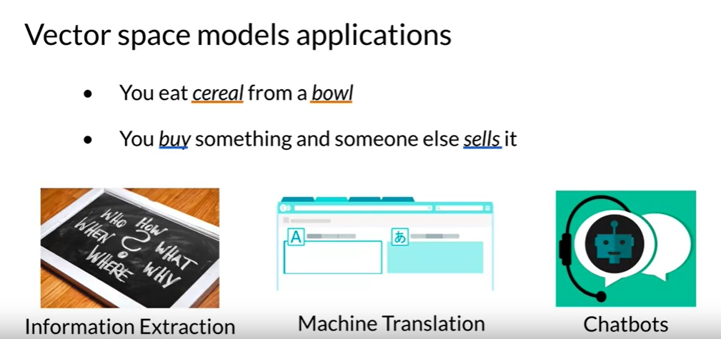

The second half of the sentence is dependent on the first half. With vectors based models, you will be able to capture this and many other types of relationships among different sets of words.

Vector space models are used in information extraction to answer questions, in the style of who, what, where, how and etcetera.

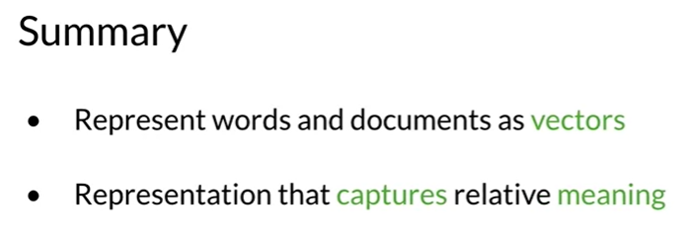

The famous quote by Firth says, **"You shall know a word by the company it keeps".** When learning these vectors, you usually make use of the neighboring words to extract meaning and information about the center word. If you were to cluster these vectors together, as you will see later in this specialization, you will see that adjectives, nouns, verbs, etc. tend to be near one another. Another cool fact, is that synonyms and antonyms are also very close to one another. This is because you can easily interchange them in a sentence and they tend to have similar neighboring words!

# Word by Word and Word by Doc.

To get a vector space model using a word-by-word design, you will make a co-occurrence matrix and extract vector or presentations for the words in your corpus.

You'll be able to get a vector space model using a word by document design using a similar approach.

Finally, I'll show you how in a vector space you can find relationships between words and vectors, also known as their similarity.

**Word by Word Design**

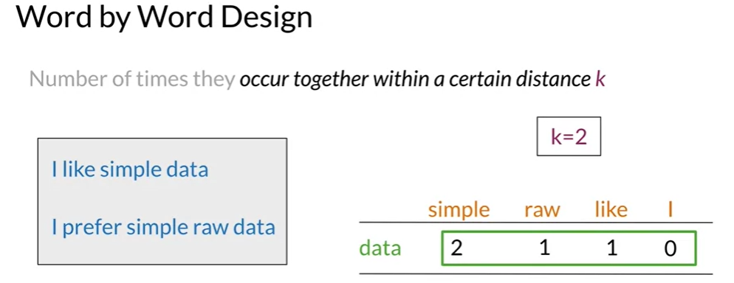

The co-occurrence of two different words is the number of times that they appear in

your corpus together within a certain word distance k.

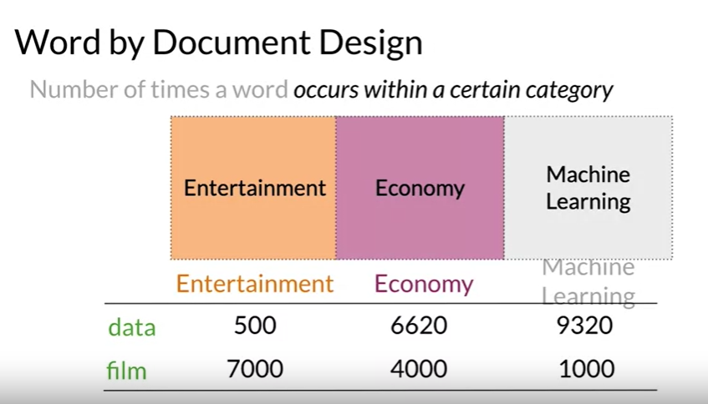

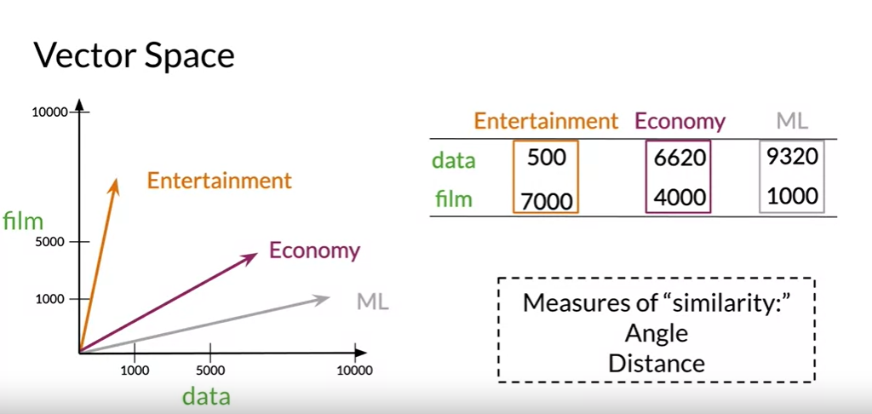

Note that in this space it is easy to see that the economy and machine learning documents are

much more similar than they are to the entertainment category.

The similarity metric is known as the Euclidean distance.

Word by Word Design

We will start by exploring the word by word design. Assume that you are trying to come up with a vector that will represent a certain word. One possible design would be to create a matrix where each row and column corresponds to a word in your vocabulary. Then you can iterate over a document and see the number of times each word shows up next each other word. You can keep track of the number in the matrix. In the video I spoke about a parameter *K*. You can think of *K* as the bandwidth that decides whether two words are next to each other or not.

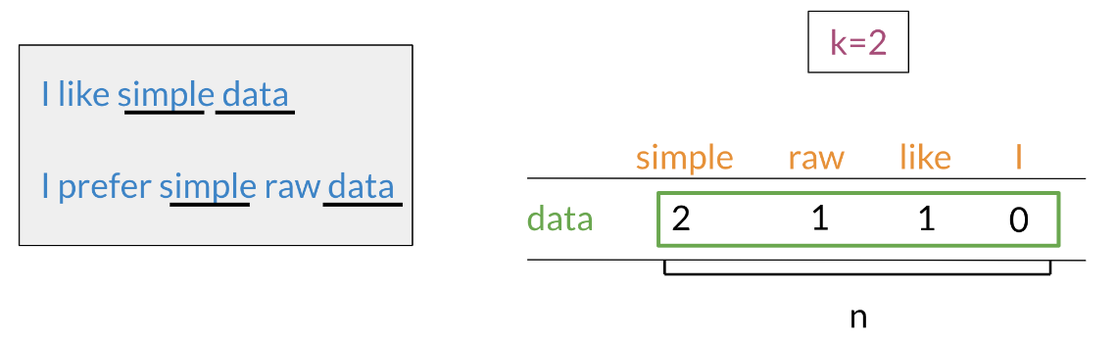

In the example above, you can see how we are keeping track of the number of times words occur together within a certain distance *k*. At the end, you can represent the word data, as a vector, *v*= [2,1,1,0].

**Word by Document Design**

You can now apply the same concept and map words to documents. The rows could correspond to words and the columns to documents. The numbers in the matrix correspond to the number of times each word showed up in the document.

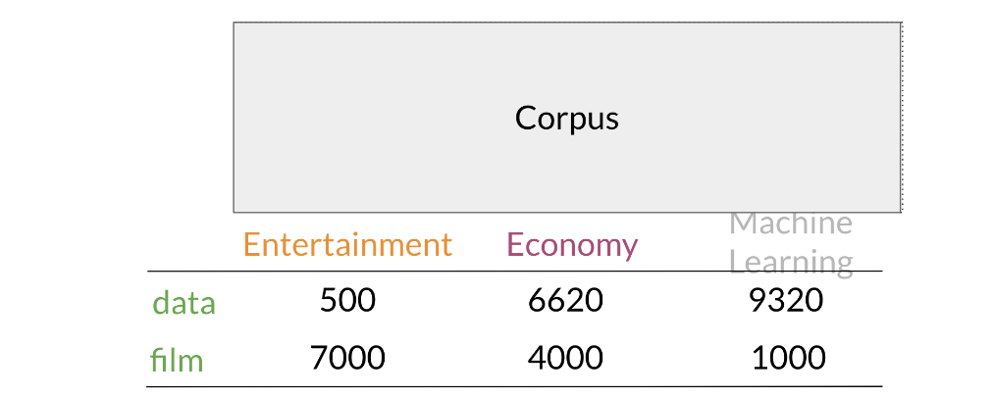

You can represent the entertainment category, as a vector *v*= [500,7000]. You can then also compare categories as follows by doing a simple plot.

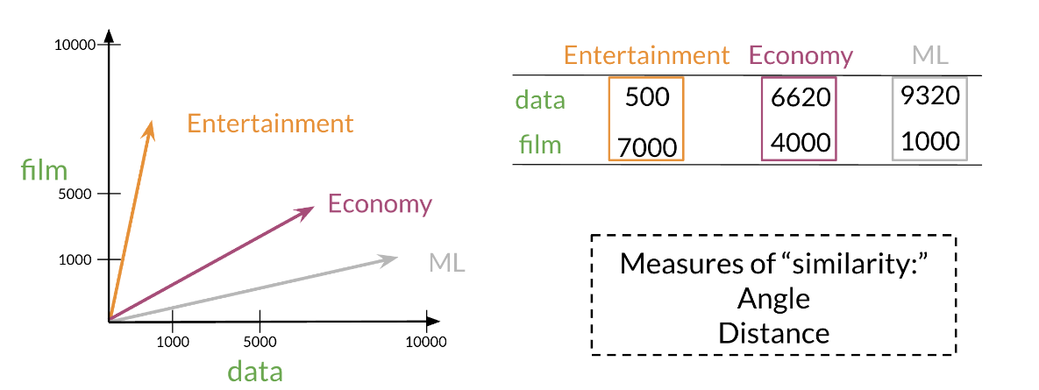

**Euclidean Distance**

* A similarity matrix
* How far 2 vectors are from each other
* How similar 2 documents or words are

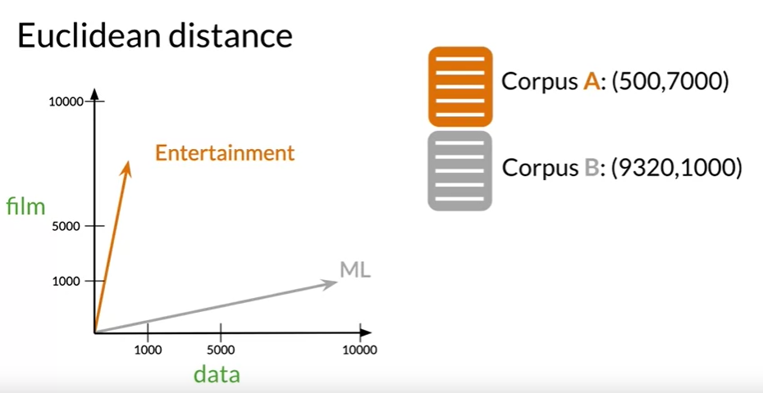

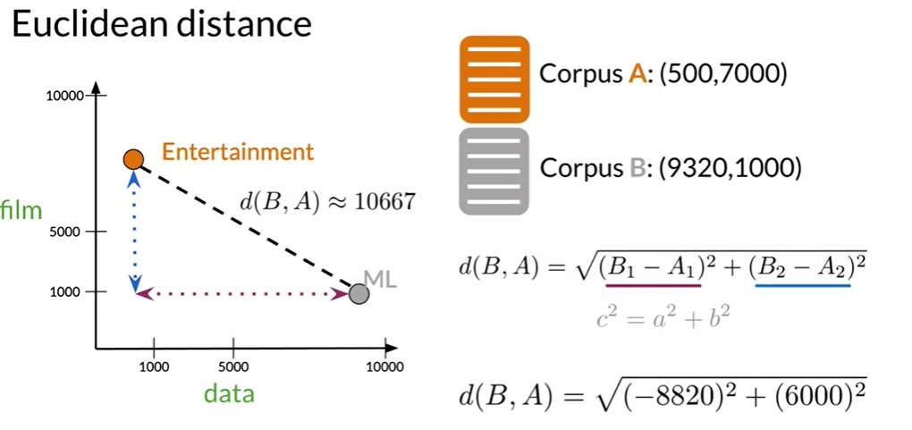

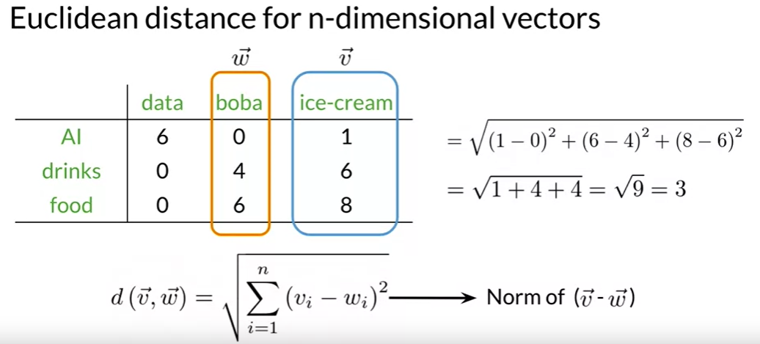

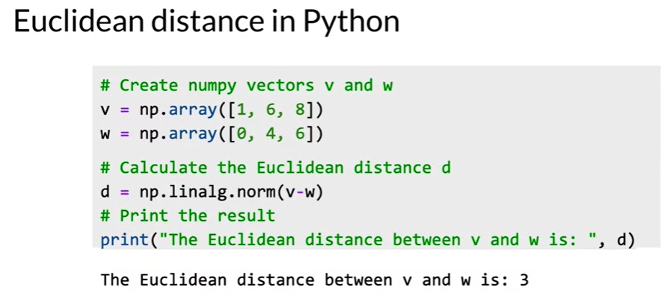

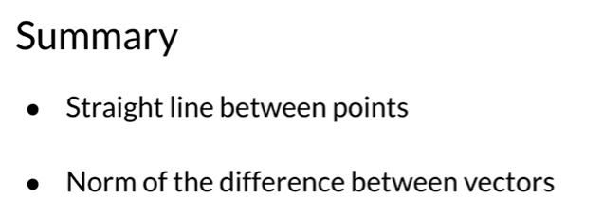

**Cosine Similarity: Intuition**

* Another type of similarity function
* It uses the cosine of the angle between the 2 vectors
* Based on that it tells whether those 2 vectors are close or not

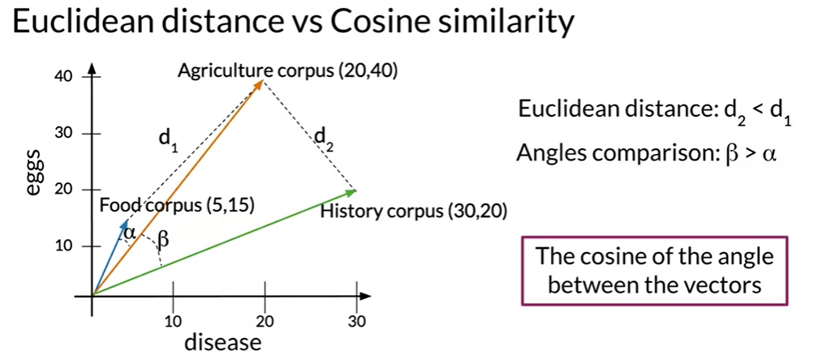

The word totals in the corpora differ from one another.

In fact, the agriculture and the history corpus have a similar number of words, while the food corpus has a relatively small number.

Let's define the Euclidean distance between the food and the agriculture corpus as d_1 and let's the Euclidean distance between the agriculture and the history corpus be d_2.

As you can see, the distance d_2 is smaller than the distance d_1, which would suggest that the agriculture and history corpora are more similar than the agriculture and food corpora.

If the angle is small, the cosine would be close to one. As the angle approaches 90 degrees,

the cosine approaches zero. As you can see here, the angle Alpha between food and agriculture is smaller than the angle Beta between agriculture and history.

In this particular case, **the cosine of those angles is a better proxy of similarity between these vector representations than their Euclidean distance.**

If you have two documents of very different sizes, then taking the Euclidean distance is not ideal. The cosine similarity used the angle between the documents and is thus

not dependent on the size of the corpuses.

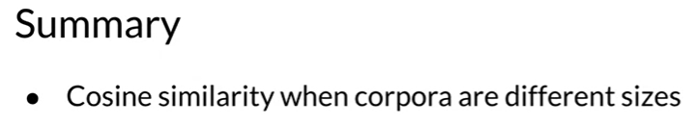

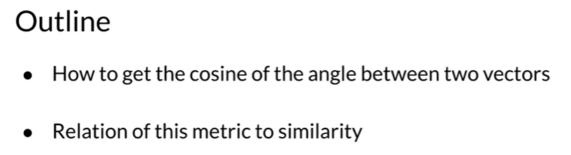

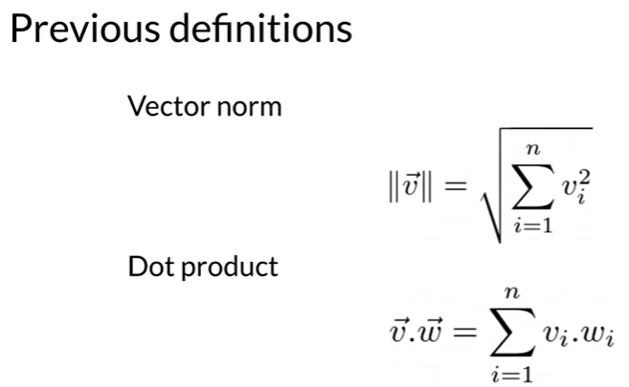

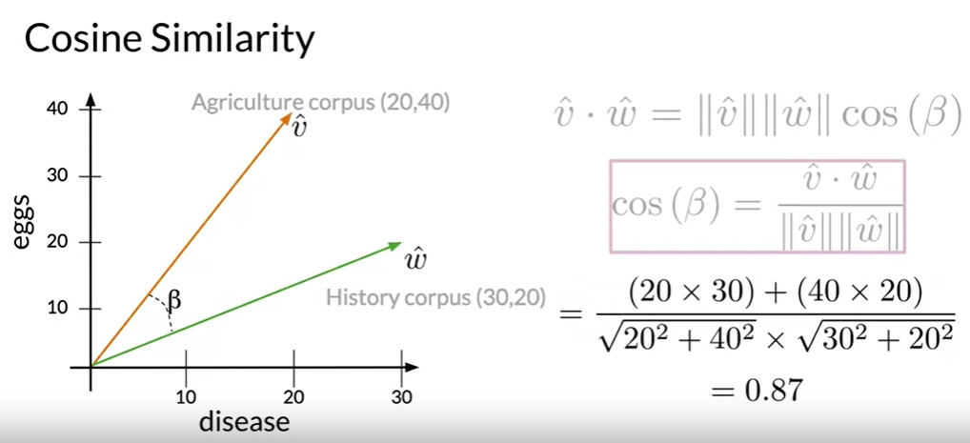

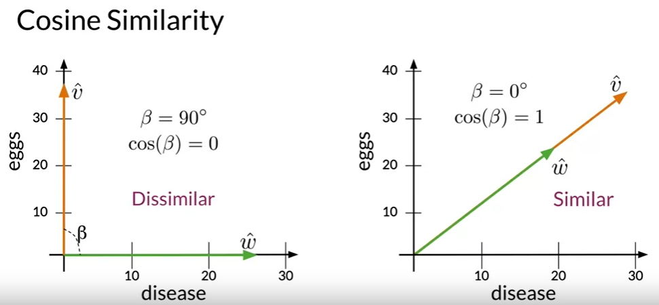

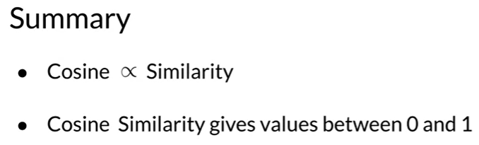

**Manipulating words in Vector spaces**

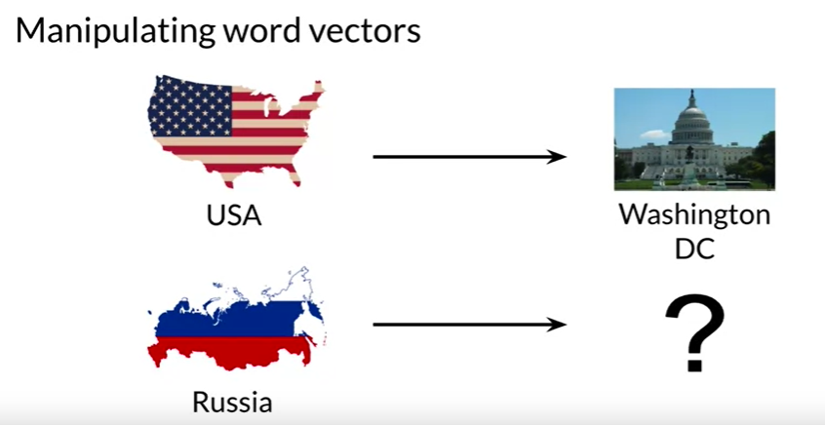

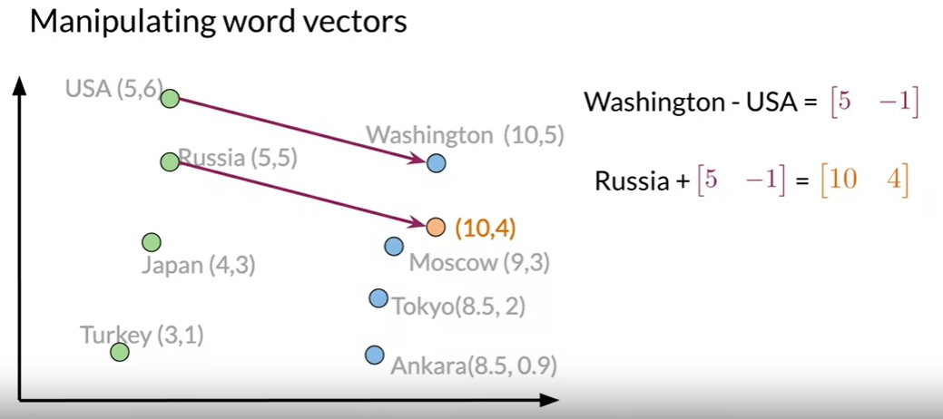

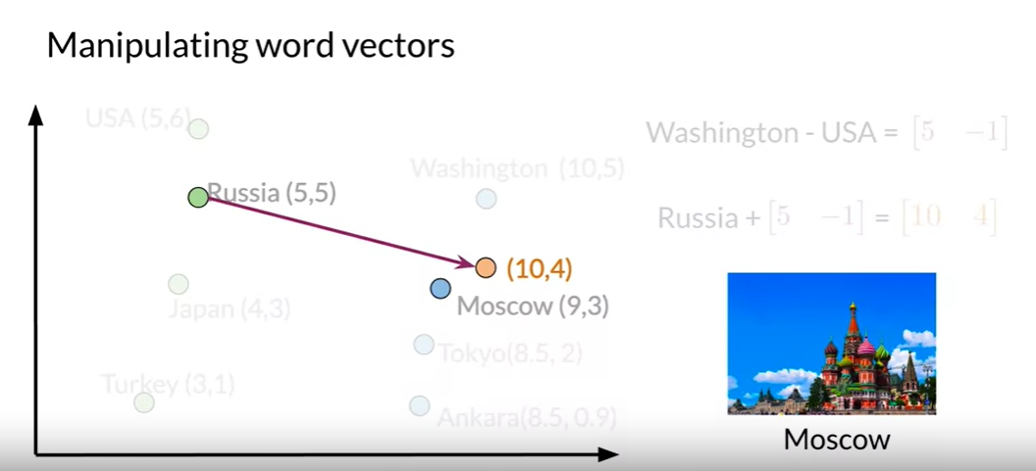

We know that the capital of the United States is Washington DC, and you don't know the capital of Russia. But you'd like to use the known relationship between Washington DC and the USA to figure it out.

For that, we'll just use some vector algebra.

For this example, we are in a hypothetical two-dimensional vector space that has different representations for different countries and capitals cities.

First, we will have to find the relationship between the Washington DC, and USA vector representations.

In other words, which vector connects them?

To do that, get the difference between the two vectors. The values from that will tell us how many units on each dimension you should move in order to find a country's capital in that vector space.

To find the capital city of Russia, we will have to sum its vector representation with the vector that you also got in the last step.

At the end, we should deduce that the capital of Russia has a vector representation of 10, 4. However, there are no cities with that representation, so we'll have to take the one that is the most similar to it's by comparing each vector with a Euclidean distances or cosine similarities.

In this case, the vector representation that is closest to the 10, 4 is the one for Moscow.

Using the simple process, we could have predicted the capital of Russia if we knew the capital of the USA.

The only catch here is that we need a vector space where the representations capture

the relative meaning of words.

Now we have a simple process to get unknown relationships between words, by the use of known relationships between others. We now know the importance of having vector spaces where the representations of words capture their relative meaning in natural language.

The vectors of the words that occur in similar places in the sentence, will be encoded in a similar way. We can take advantage of this type of consistency encoding to identify patterns.

For example, if we have the word doctor and we are to find the closest words that are closest to it by computing cosine similarity, We might get the word doctors, nurse, cardiologist, surgeon, etc.

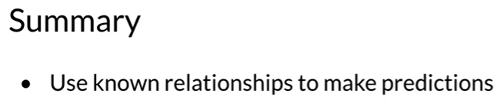

VISUALIZATION AND PCA

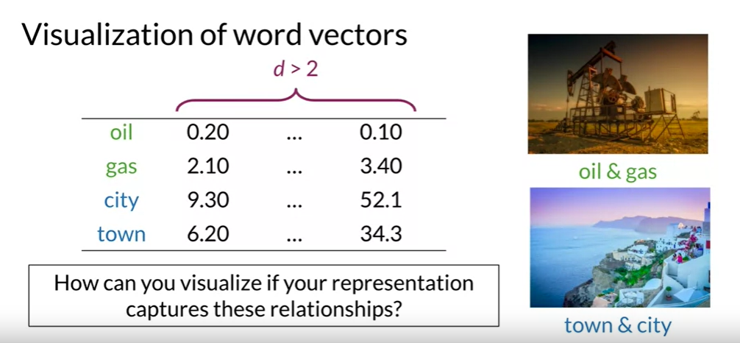

Imagine we have the following representation for words in a vector space.

In this scenario, the vector space dimension is higher than two that the words oil and gas and city and town are related. And you want to see if that relationship is captured by the representation of your words.

So how could we visualize your words in order to see this and other possible relationships, dimensionality reduction is a perfect choice for this task.

When we have a representation of the words in a high dimensional space, we could use an algorithm like PCA to get a representation on a vector space with fewer dimensions.

If we want to visualize the data, we can get a reduced representation with three or fewer features. If we perform principal component analysis on the data and get a two dimensional representation, we can then plot a visual of your words.

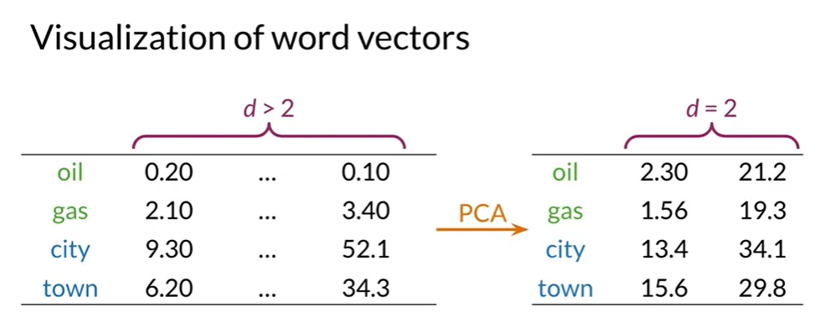

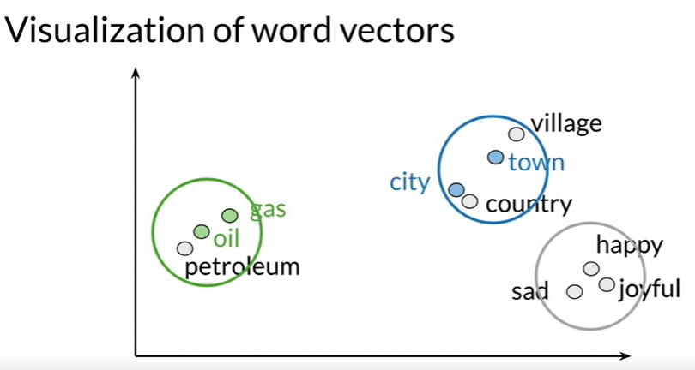

In this case, we might find that the initial representation captured the relationship between the words oil and gas and city and town. Because in the 2 dimensional space they appear to be clustered with related words. We can even find other relationships among your words that we didn't expect.

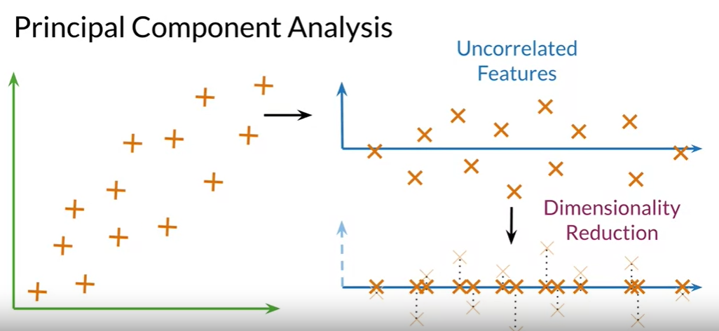

For the sake of simplicity, we'll begin with a two dimensional vector space.

Say that we want the data to be represented by one feature.

Instead using PCA.

First, we'll find a set of un correlated features and then project the data to a one dimensional space trying to retain as much information as possible. As we can see, this process is quite straightforward.

We'll also project our data for a representation in a lower dimension while retaining as much information as possible.

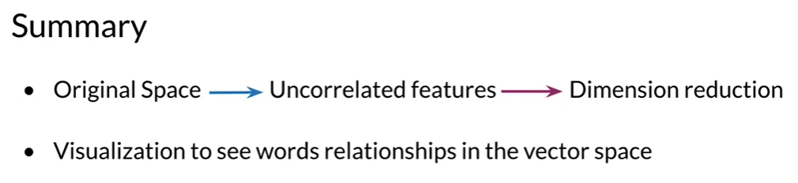

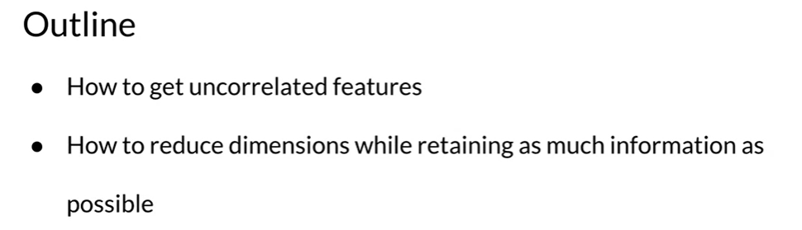

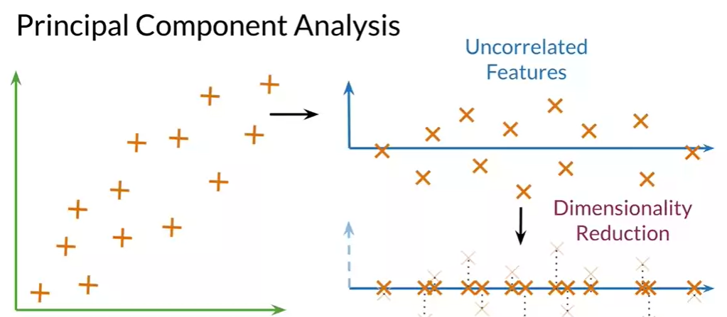

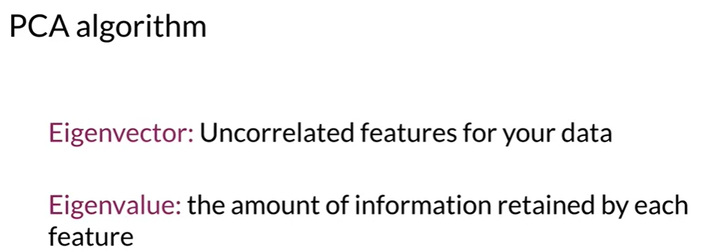

To perform PCA, we will need to get the Eigenvectors and Eigenvalues from the co variance matrix of your data.

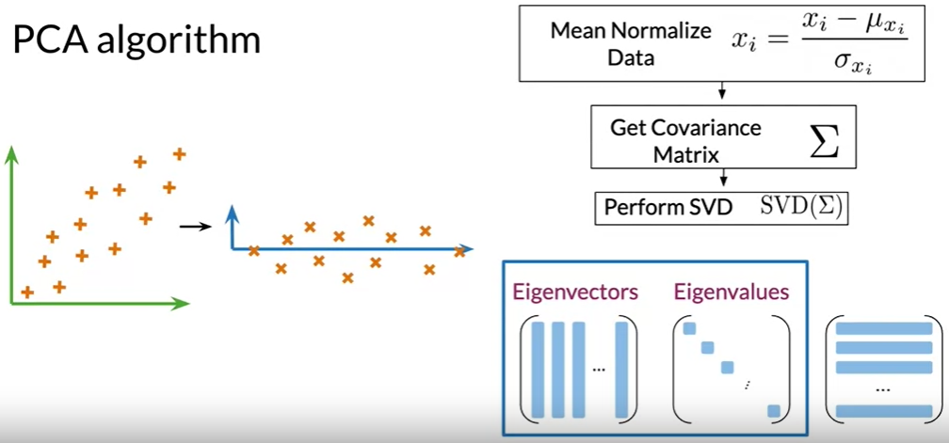

The first step is to get a set of uncorrelated features for this step, you mean normalize your data, then get the covariance matrix. And finally perform a singular value decomposition to get a set of

three matrices.

WEEK 4

MACHINE TRANSLATION AND DOCUMENT SEARCH

Quick nearest neighbor search using locally sensitive hashing.

For example, you will translate one word from one language to another by manipulating word vectors. If you have a set of English word vectors and a set of equivalent French word vectors,

you want to learn a mapping from an English vector to the French vector.

To do k-nearest neighbors very quickly and with a technique known as locality sensitive hashing.

This technique allows you to split your search range into similar regions. Given an input, you can search for it in the most likely region that it's going to appear.

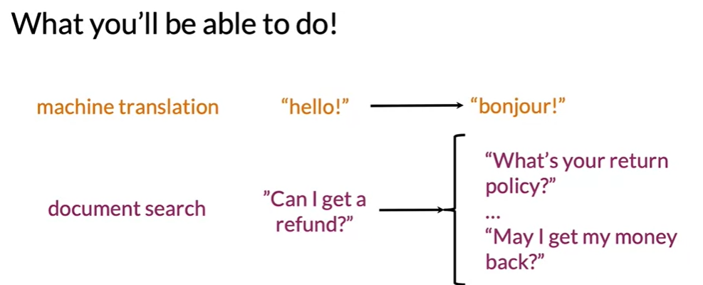

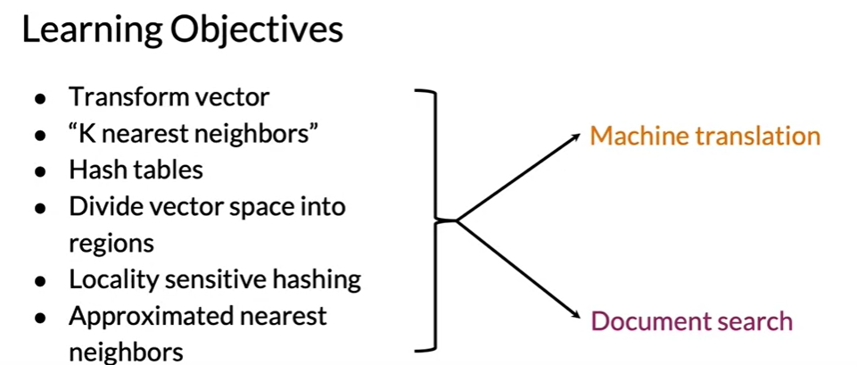

**TRANSFORMING OF WORD VECTORS**

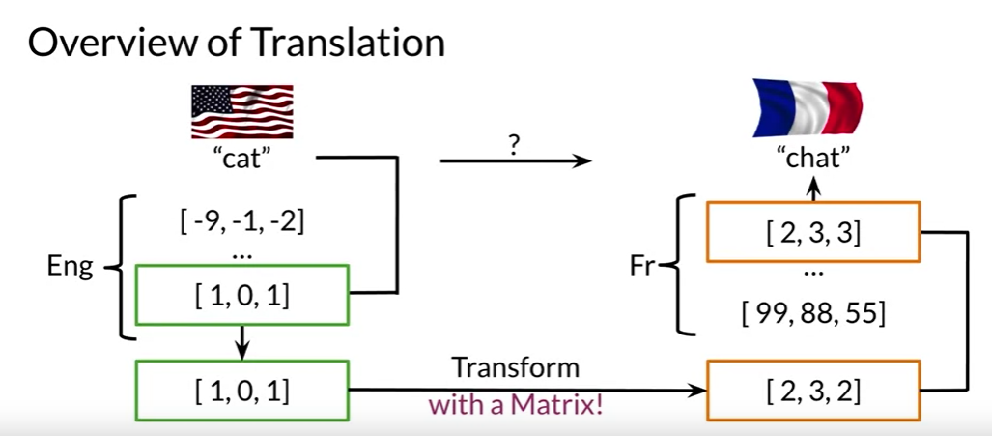

In order to translate an English word to a French word.

One way would be to generate an extensive list of English words and their associated French word. If you ask the human to do this, you would find someone who knows both languages to start making a list.

If you want a machine to learn how to do this, you would calculate word embeddings associated with English and word embeddings associated with French.

Next retrieve the English word embedding of a particular English word such as cat. Then find some way to transform the English word embedding into word embedding that has the meaning in the French word vector space.

We will see how to convert from the English word vector space to the French word vector space in the moment.

Next, you'll take the transformed word vector and search for word vectors and the French word vector space that are most similar to it.

The most similar words are candidates words for your translation. If your machine does a good job, it may find the word chat which is the French word for cat. You want to find the matrix that can do this transformation for you.

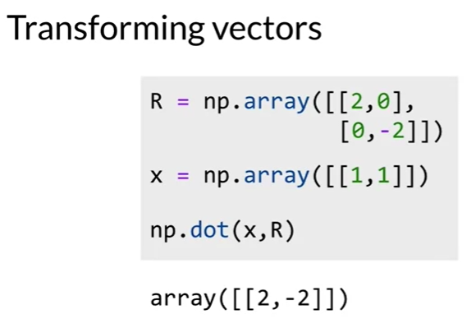

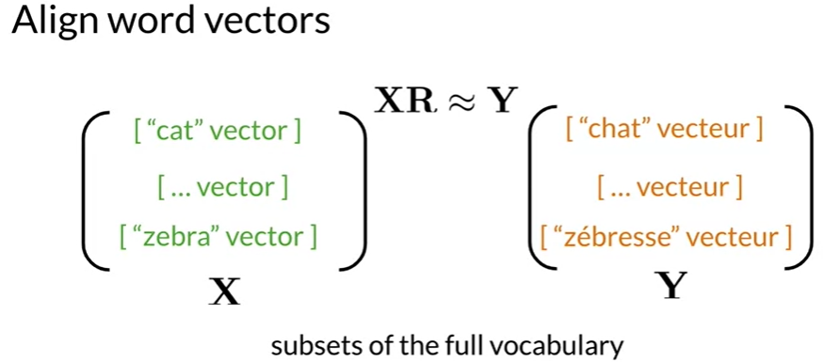

We can start with a randomly selected matrix R and then see how it performs. When you try to translate the English vectors in matrix X and compare that to the actual French word vectors which is in the matrix Y. In order for this to work, you will first need to get a subset of English words and their French equivalents. Get their respective word vectors and stack the word vectors in the respective matrices, X and Y. The key here is to keep the roads lined up, or to align the word vectors. This means that if the first row of matrix X contains the word cat, then the first

row of the matrix Y should contain the French word for cat which is chat. Now you may be asking wait a minute. If I already have the English words and their French translations, why do I need to train a model to do this? Why not just save this information in a key value mapping like a python

dictionary? Well, the nice thing is that you can just collect a subset of these words to find your transformation matrix. And if it works well, then the model can be used to translate words that are not part of your original training set.

So you only need to train on a subset of the English French vocabulary and not the entire vocabulary.

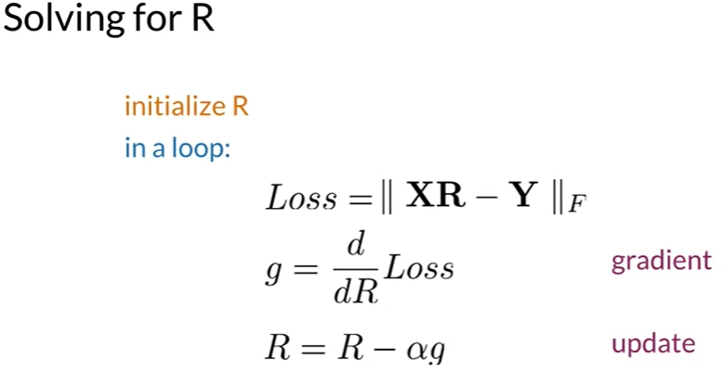

Think of Loss as a measure of how far apart the attempted translation and the actual French vectors are.

If you start with a random matrix R, you can gradually improve these matrix R in a loop.

First compute the gradient by taking the derivative of this loss function with respect to the matrix R. Next update the matrix R by subtracting the gradient, but note that it's the gradient weighted by the learning rate alpha. You can either pick a fixed number of times to go through the loop or

check the loss at each iteration. And break out of the loop when the loss falls between a certain threshold.

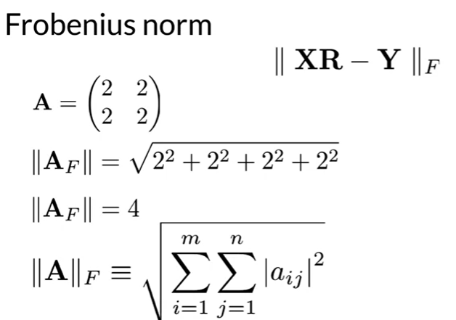

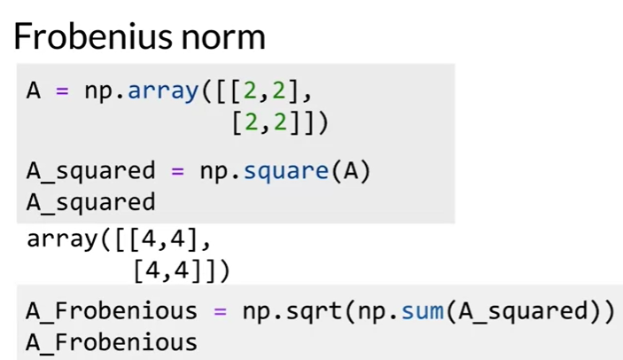

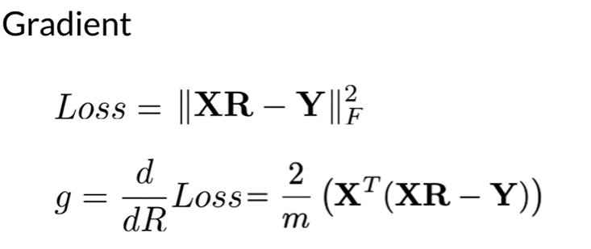

In summary you are making use of the following:

* XR≈Y
* minimize ∥XR−Y∥2F

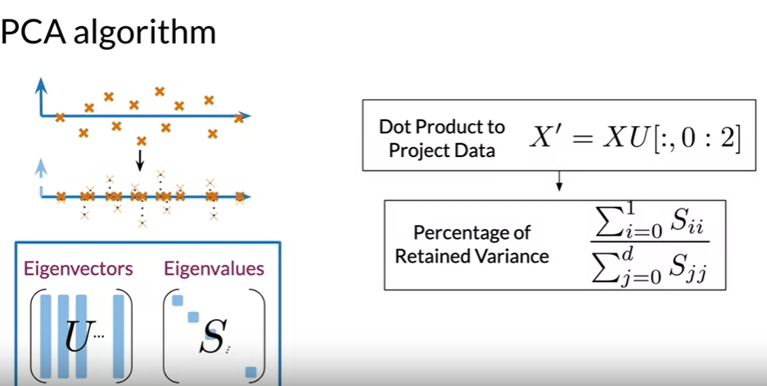

The next step is to project your data to a new set of features.

We will be using the Eigenvectors and Eigenvalues in this step, let's denote the Eigenvectors with U and the Eigenvalues with S.

First, you will perform the dot products between the matrix containing your word embeddings and the first n columns of the U matrix. Where N equals the number of dimensions that you want to have at the end.

For visualization, it's common practice to have two dimensions, then you'll get the percentage of variants retained in the new vector space. As an important side note, your Eigenvectors and Eigenvalues should be organized according to the Eigenvalues in descending order. This condition will ensure that you retain as much information as possible from your original embedding.

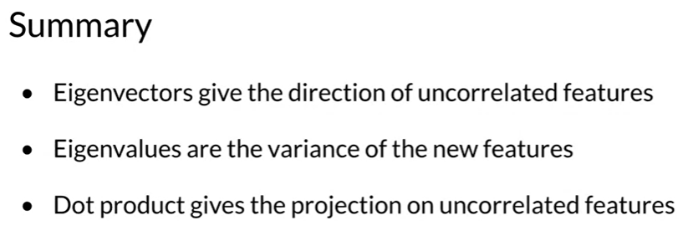

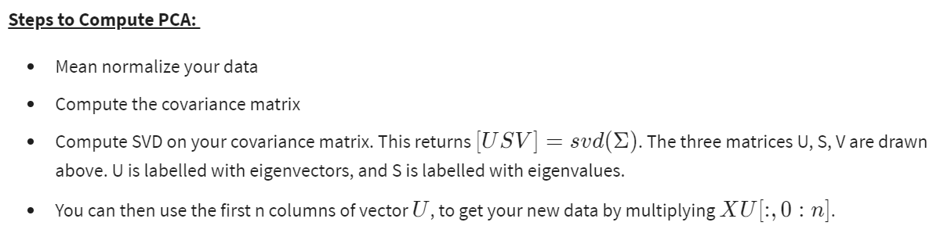

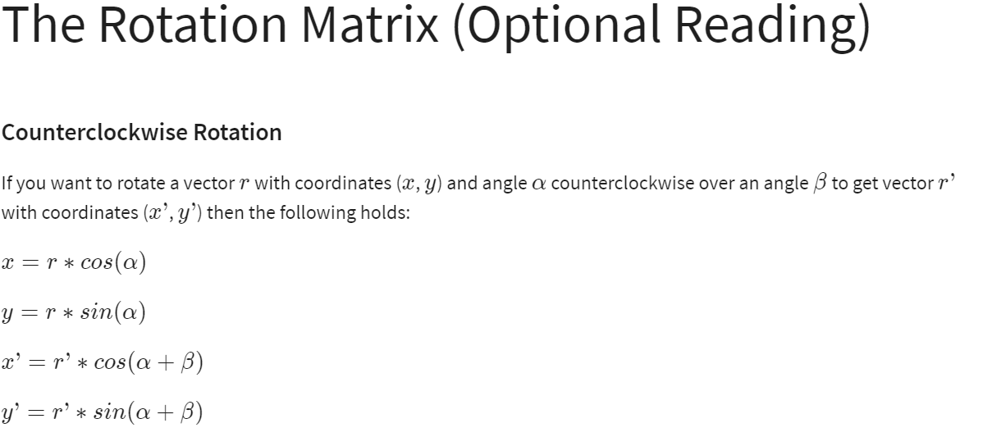

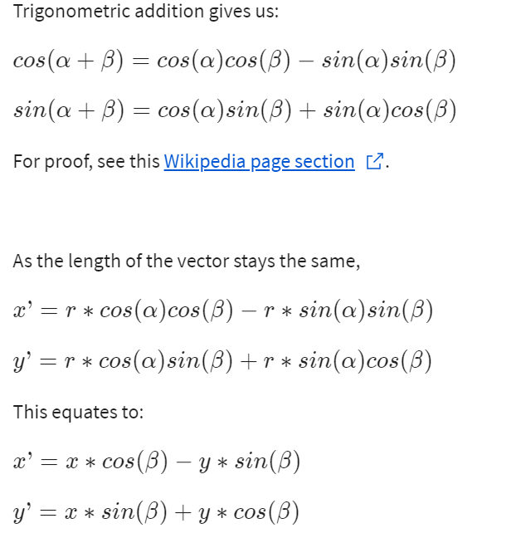

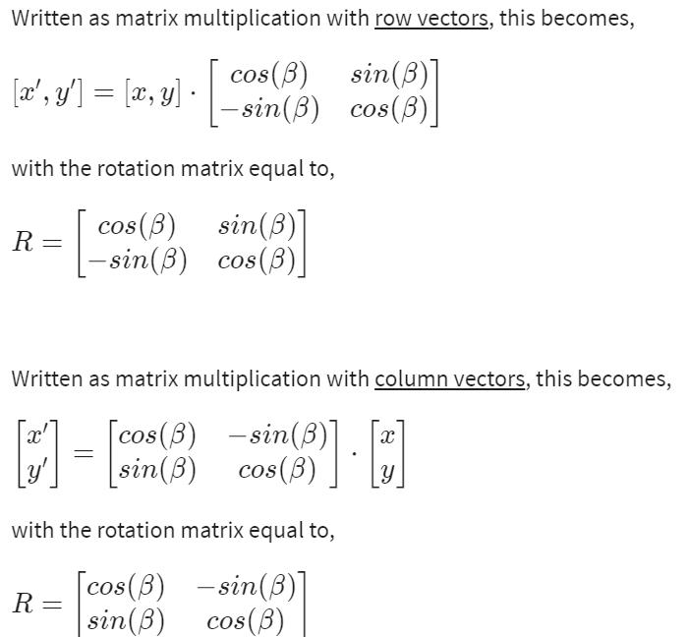

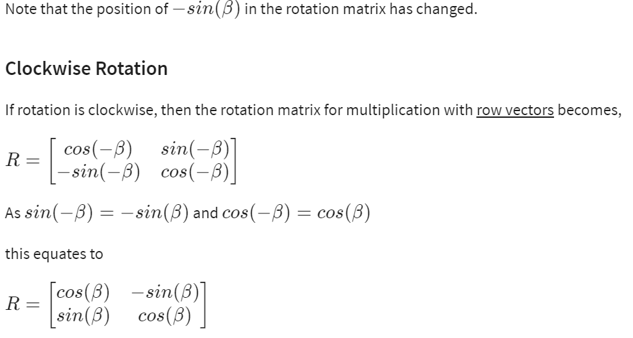

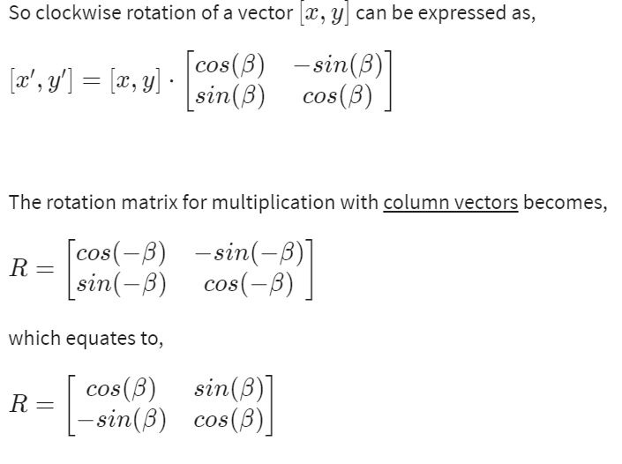

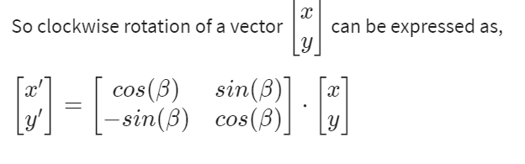

**K- Nearest Neighbors**

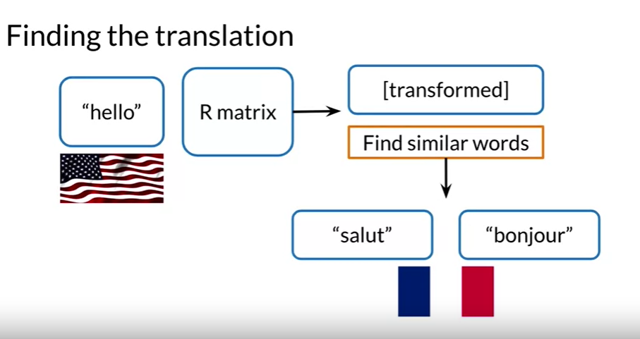

That a transform or the vector after the transformation, if it's embedding through an R matrix,

would be in the French word vector space. But it is not going to be necessarily identical

to any of the word vectors in the French word vector space. You need to search through the actual French word vectors to find a French word that is similar to the one that you created from the transformation. You may find words such as salut or bonjour which you can return as the French translation of the word hello. So the question is, how do you find similar word vectors

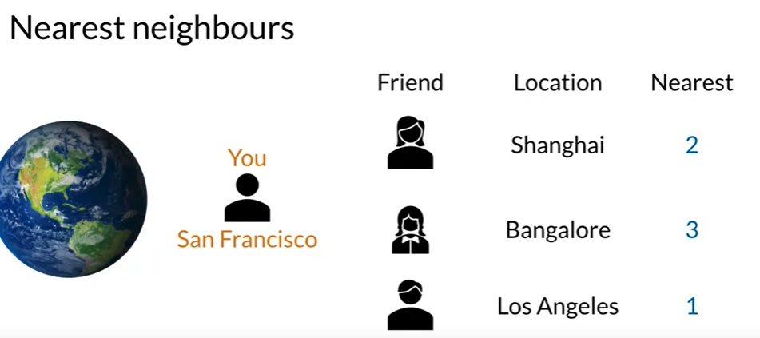

Let's pretend that you are visiting San Francisco in the United States and you're visiting your dear friend Andrew. You also want to visit your other friends over the weekend, preferably those who live nearby. One way to do this is to go through your address book, and for each friend, get their address, calculate how far they are from San Francisco.

One friend is in Shanghai, the other friend is in Bangalore, and another friend is in Los Angeles.

You can sort your friends by their distances to San Francisco, then rank them by how close they are. Notice that if you have a lot of friends, which I'm sure you do, this is a very time intensive process. Is there a more efficient way to do this? Notice that two of these friends live in another continent, while the third friend lives in the United States. Could you have just searched for a subset of friends who live in the United States.

You might have realized that it may not have been necessary to go through all of your friends in your address in order to find the ones closest to you. You might have imagined if you somehow could filter on which friends were all in a general region such as North America, then you could just search within that subgroup of friends.

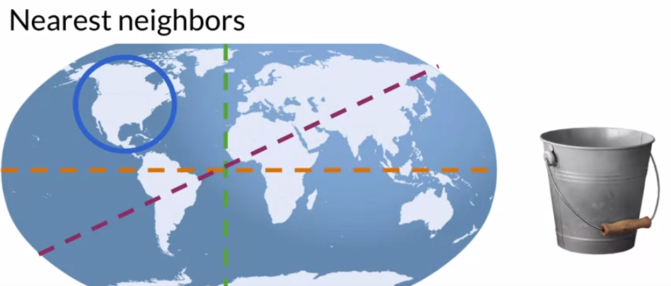

If there is a way to slice up the geographic space into regions, you could search just within those regions. When you think about organizing subsets of a data-set efficiently, you may think about placing your data into buckets. If you think about buckets, then you'll definitely want to think about hash tables. Hash tables are useful tools for any kind of work involving data. You'll learn about hash tables next.

A hash table, also known as a hash map, is a data structure that implements an associative array, also called a dictionary, which is an abstract data type that maps keys to values.

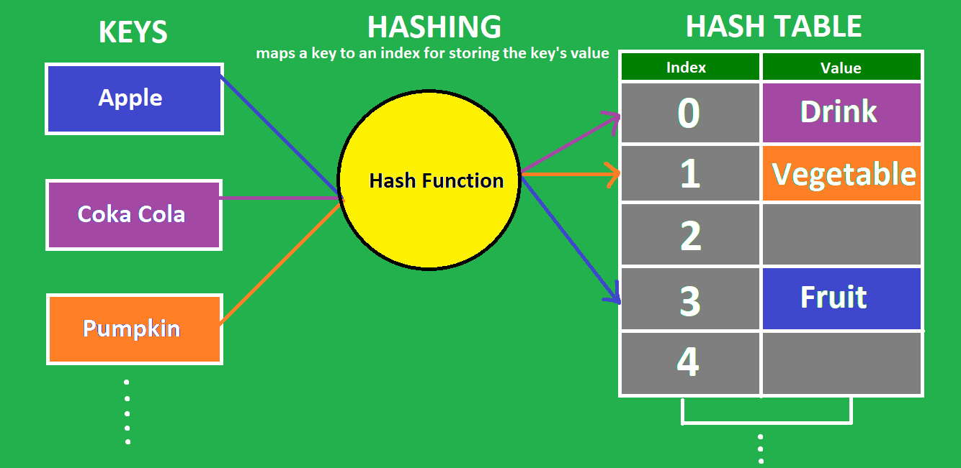

**HASH TABLE AND HASH FUNCTIONS**

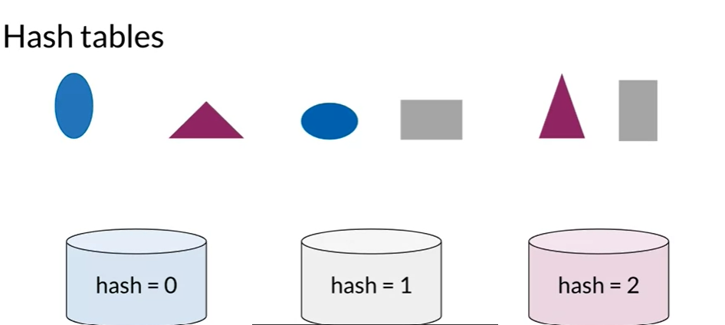

You have several data items and you want to group them into buckets by some kind of similarity.

One bucket can hold more than one item, and each item is always assigned to the same bucket.

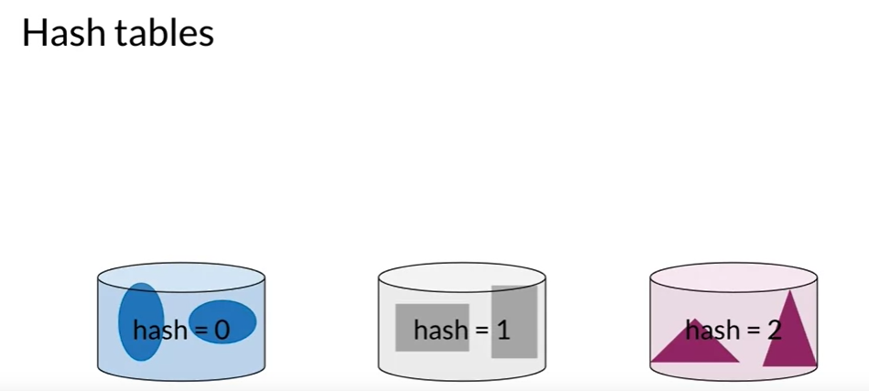

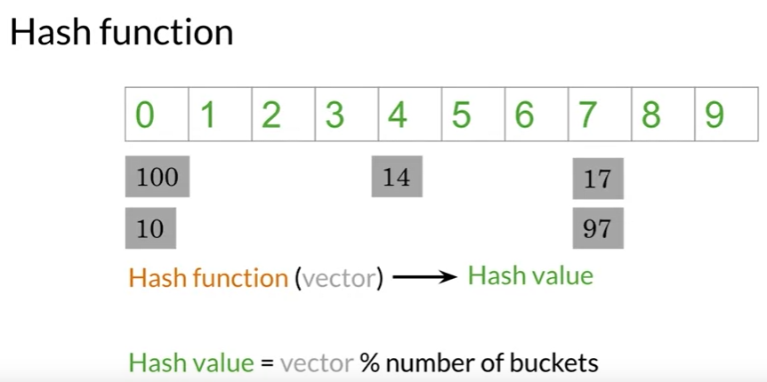

let's assume that the word vectors have just one dimension instead of 300 dimensions so each word is represented by a single number, such as 100, 14, 17, 10, and 97.

You need to find a way to give each vector a hash value which is a key that tells us which bucket it's assigned to.

**A function that assigns a hash value is called a hash function.**

In this example, here is a hash table which is a set of buckets. In this case, the hash table has 10 buckets. Notice how the word vectors 100 and 10 are assigned to bucket 0. The word vector 14 is assigned to bucket 4 and the word vectors 17 and 97 are assigned to bucket 7.

Do you notice a pattern? This formula here is the hash function that's being used to assign the word vectors to their respective buckets.

The modulo operator takes the remainder after dividing by 10. The remainder is the hash value that tells us where the word vector should be stored.

For example, 14 divided by 10 has a remainder of 4 so it goes to bucket 4.

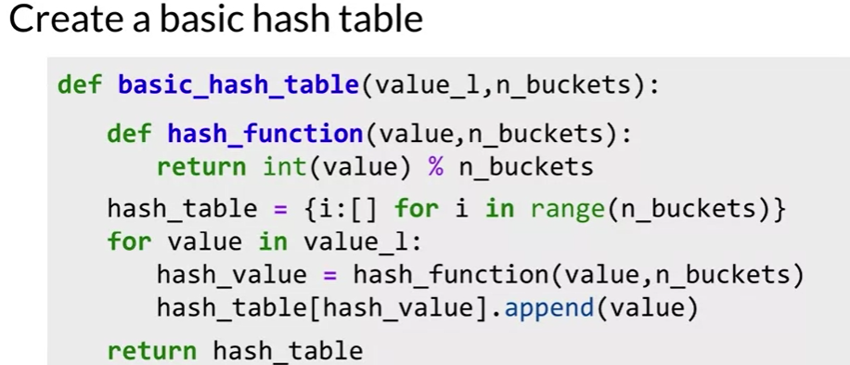

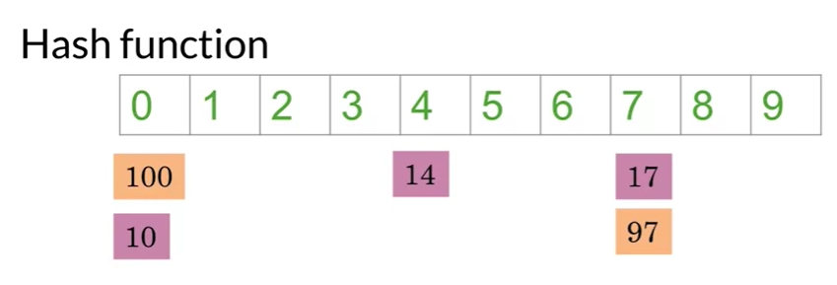

So locality-sensitive hashing is a hashing method that cares very deeply about assigning items

based on where they're located in vector space.

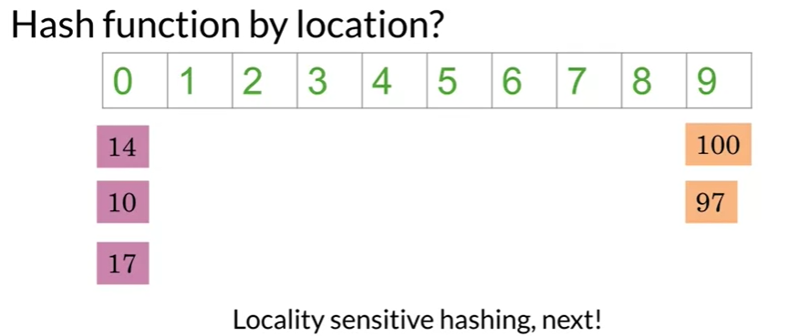

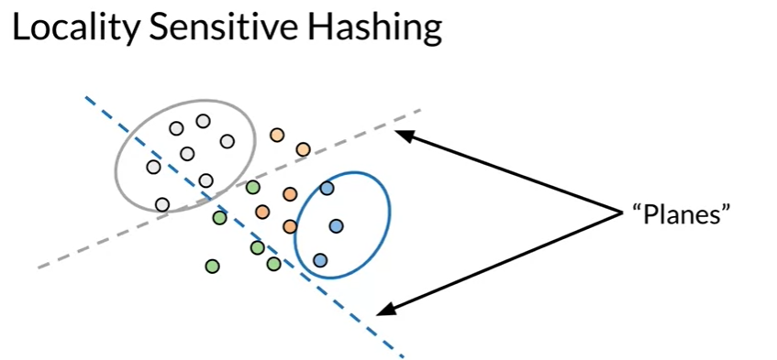

Locality sensitive hashing - Reduce the computational cost of finding neighbours in high dimensional spaces. It is sensitive to the location of the items that it’s assigning into buckets.

Let's first assume that you're using word vectors with just two dimensions.

Other pits each vector as a circle instead of arrows.

Let's say you want to find a way to know that these blue dots are somehow close to each other, and that these grey dots are also related to each other. First divide the space using these dashed lines, which I'll call planes. Notice how the blue plain slices up the space into vectors that are above it or below it.

The blue vectors all happen to be on the same side of the blue plane.

Similarly, the grey vectors happen to be above the grey plane.

It looks like the planes can help us bucket the vectors into subsets based on their location, this is exactly what you want.

A hashing function that is sensitive to the location of the items that it's assigning into buckets.

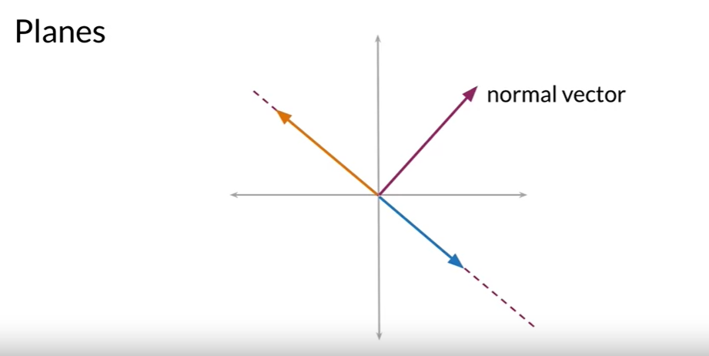

The normal vector is perpendicular to any vectors that lie on the plane.

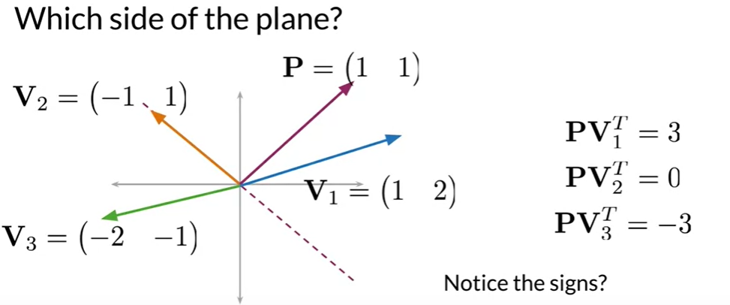

When the dot product is positive, the vector is on one side of the plane. If the dot product is negative, the vector is on the opposite side of the plane. If the dot product is zero, the vector is on the plane.

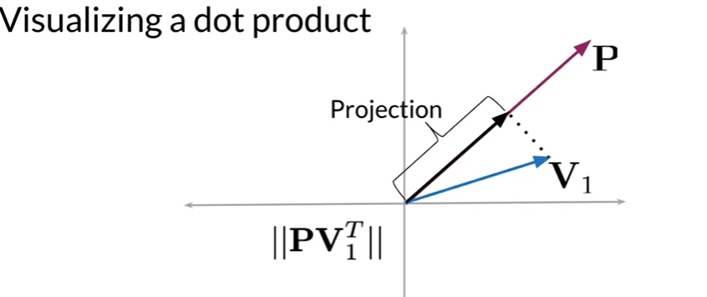

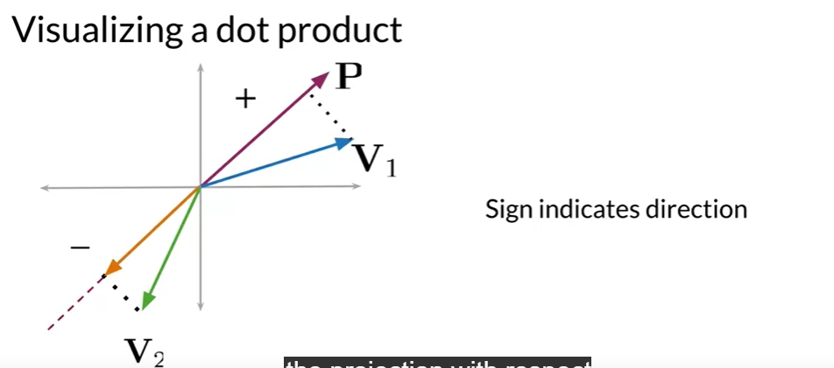

The main takeaway is that the sign of the projection of two vectors tells you which

parts of the line the point lies.

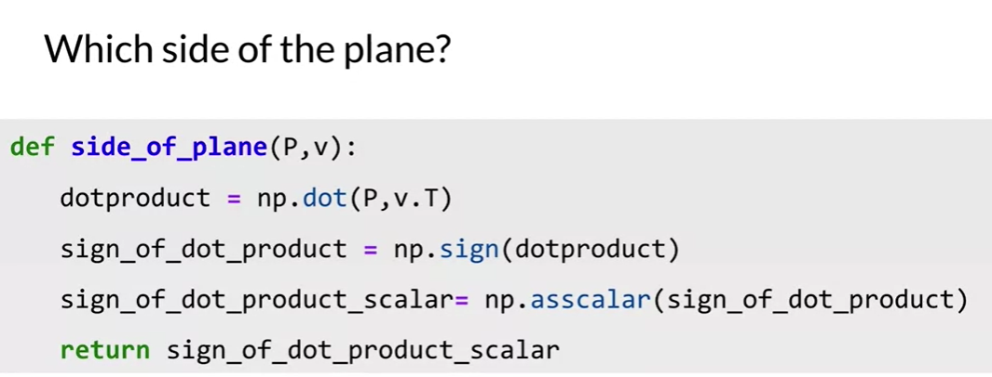

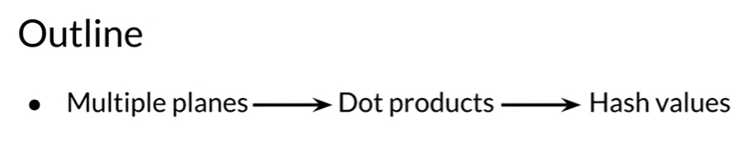

In order to divide your vector space into manageable regions, you'll want to use more than one plane.

For each plane, you can find out whether a vector is on the positive or negative side of that plane.

You'll get multiple signals, one, for each plane and you want to find a way to combine all of those signals into a single hash value.

This hash value will define a particular region within the vector space.

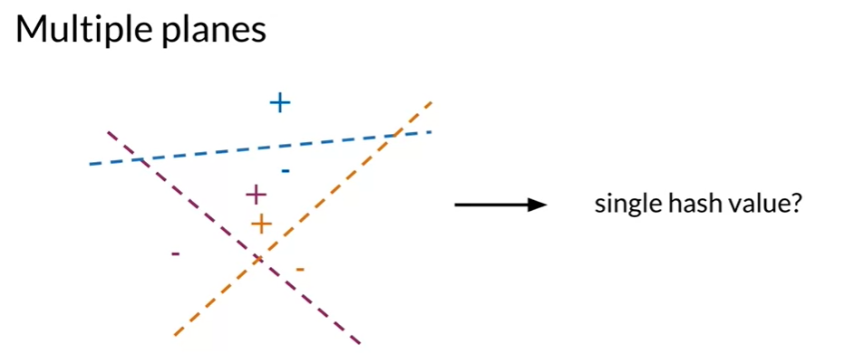

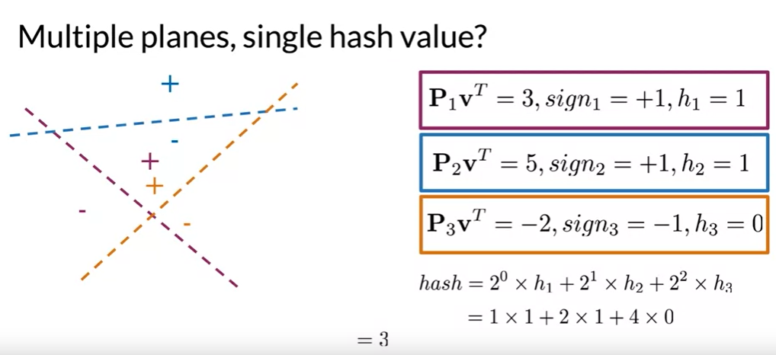

If the sign of the dot product is greater than or equal to zero, assign the intermediate hash value of one. Otherwise, if the dot product is less than zero, assign the intermediate hash value of zero. To combine the intermediate hash values, use the formula.

This is how we get locality sensitive hashing.

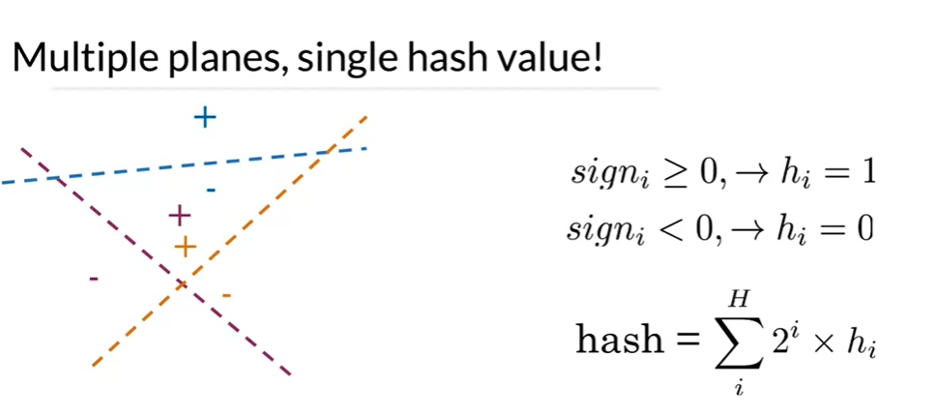

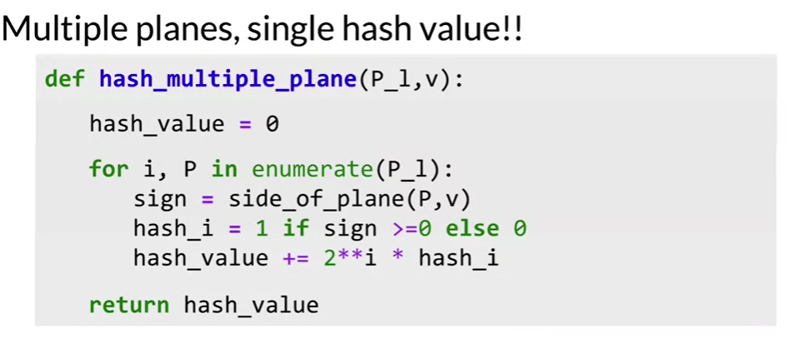

**P_l** is the list of planes. You initialize the value to 0, and then you iterate over all the planes (P), and you keep track of the index. You get the sign by finding the sign of the dot product between v and your plane P. If it is positive you set it equal to 1, otherwise you set it equal to 0. You then add the score for the ith plane to the hash value by computing 2**i*hash_i.

Approximate Nearest Neighbors

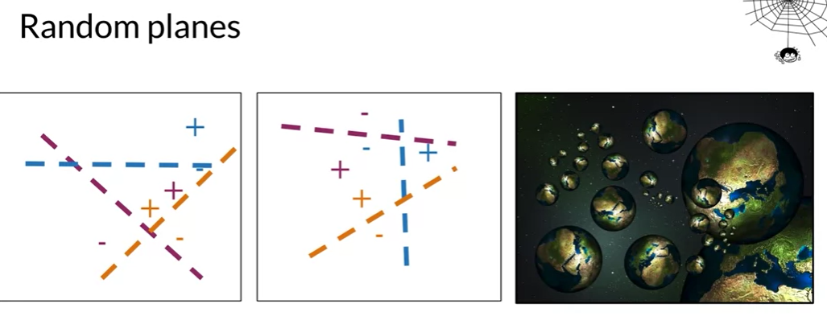

Such as these three can divide the vector space into regions. But are these planes the best way to divide up the vector space? What if instead, you divided the vector space like this?

In fact, you can't know for sure which sets of planes is the best way to divide up the vector space. So why not create multiple sets of random planes. So that you can divide up the vector space into multiple independent sets of hash tables. You can think of it like creating multiple copies of the universe or a multiverse, if you will.

You can make use of all these different sets of random planes, in order to help us find a good sets of friendly neighbourhood vectors. I mean, a set of k nearest neighbours.

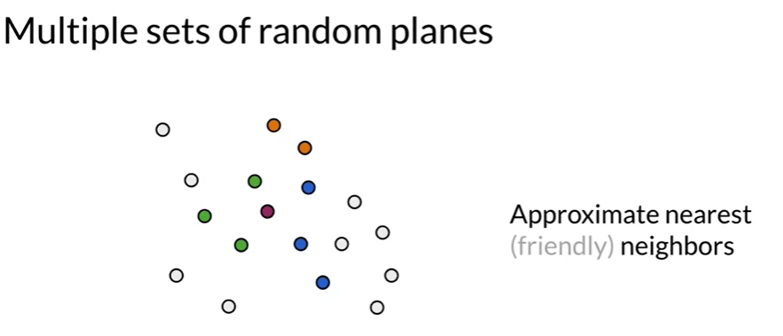

Helped us to determine that this magenta vector and these green vectors are all assigned to the same hash pockets. Another entirely different sets of random planes, helped us determine. That these blue vectors are in the same hash pockets as the red vector. A third set of random planes, helped us determine that these orange vectors are in the same hash pockets as the magenta vector.

By using multiple sets of random planes for locality sensitive hashing. You have a more robust way of searching the vector space, for a set of vectors that are possible candidates to be nearest neighbors. This is called **approximate nearest neighbors**, because you're not searching the entire vector space but just a subset of it. So it's not the absolute k nearest neighbors but it's approximately the k nearest neighbors.

You sacrifice some precision in order to gain efficiency in your search.

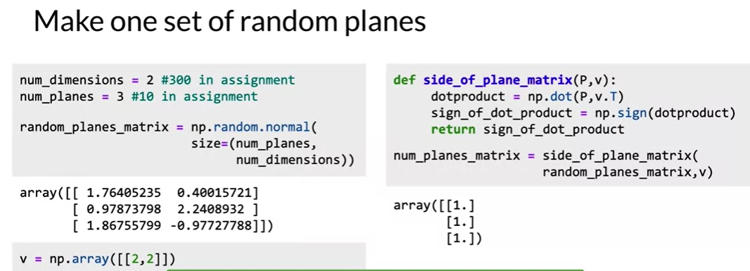

You can find the word vectors for each individual word. I love learning then just add them together. So the sum of all these word vectors becomes a document vector with the same

dimension as the word vectors. In this case, three dimensions. You can then apply document search by using k-nearest neighbors.

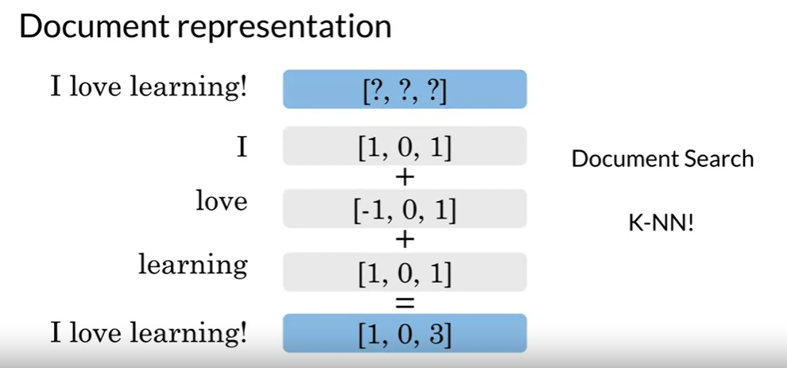

So in summary you should now be familiar with the following concepts:

